Roles- Role- 1-
- First up all I would like to thank you for this opportunity
- I have around 5+ years of experience in IT industry as Snowflake ETL development with the skill set of snow-sql, snow pipe integration with the AWS and other clouds and also I have secondary skills of oracle sql and PLSQL, snowflake sql also
- I’m handling banking related projects and validated huge volume of data in the source and target environments.
- So that, I have used Oracle Sql and snowflake sql to migrate and validate various data environments
- I have worked into various schema architecture like Fact table, dimension tables, Star schema and snowflake schemas.
- I have involved Data Migration from Oracle Database to Snowflakes using IICS for application Migration from Oracle DB to Snowflake.
- I have Experience in Snowflakes Object Development such as
Tables, Views, Pipes, Stages, procedures, functions
- Created External table to access the data from the files, when the file access is denied in AWS S3.
- Created Snow Pipe to read the data from the AWS S3 and loaded the data to Snowflake DB
To ensure the continuous data integration between the oracle and snowflake DB.
- Created snow tasks as task tree to read the data from the snow stream objects
Which are created on the base table, to maintain the backup of data while happening DML operation in the target snowflake DB.
- Used secure views and materialized views to share the data to the partner application as per the data requests.
- We are using JIRA as ticketing tool
- I also used IICS tool for migration, GITHUB desktop for version control tool and we follow agile scrum methodology
- That’s short about me, Thanks!

Roles- Role- 2-
- I am having __+ years of experience in IT industry as SNOWFLAKE and ETL developer.
- I currently work for ___________
- My skills are Snowflake SQL , Snowflake Object development and Oracle SQL, PLSQL, AWS s3, SQS, IAM, IICS.
- I have Involved in data loading like structured files like CSV and Semi structured files like Json, Parquet files etc from AWS s3
- Done active and passive transformations and ensured the data quality between the source and target.
- I developed snowflake objects like Snowpipe continuous loading, file formats, stages and used copy command to load the data from stage to the table.
- I utilized time travel option in snowflake and zero copy to clone the table with zero size.
- I am familiar with data warehousing concepts like star schema, Snowflake schema, Dimension tables, Fact tables.
- Developed secure Views and materialized views to share the data to the partner applications.
- Created stream to track the DML changes on a table and created task for scheduling purpose.
- Created complex sql using the functions like Aggregate and window functions. And also, I have worked with set operators, single row functions, joins, Sub queries etc.
- Involved in development of few more objects like procedures and Functions where we have handled business logics.
- We follow Agile scrum methodology with three weeks of sprint.
- These are my roles and responsibilities, thank you

Roles- Role- 3-
- Myself _______, working for ________ having relevant of around _+ years of experience as a snowflake developer
- I have experience in snowflake and Oracle databases specialized in technologies Snowflake SQL as scripting language to develop objects like procedures and functions.
- Also, worked with Oracle SQL, PLSQL along with data warehousing concepts like Star schema, Snowflake schema, OLTP and OLAP.
- I have involved in query optimisation in Snowflake based on the query profile.
- I have created External stage and transformed the data based on the business rule in the integration layer.
- Converted the business need into technical complex SQL queries and subqueries using analytical functions, Joins, Set operators.
- Involved Utilization, Roles, Data migration for Structured Data: By creating Stage & Copy, Transforming.
- Data, Copy on Error, File Format & all Copy Options.
- I Have hands on Experience on Loading semi structured data on minimal load using
VARIANT Datatype, Flatten function, also handled Parquet files, etc.
- Developed Snowflake Procedures, Functions and UDTF (User Defined Table Function)
- I have created documents like Impact Analysis Document, Technical design document and mapping document.
- That’s it from my side!

Snowflake as Cloud data warehouse- Introduction
It can build on top of any cloud as AWS, AZURE and GCP
SAAS – Software as services
- SaaS is not required any of the software installation
- Ongoing maintenance, management, upgrades and tuning everything will be handled by the snowflake
Snowflake is a single platform for the DW, DL, Data engineering, APP Development and Secure, share & consumption of real time data.
To maintain the traditional data base or warehouse we need the resources like
Database, hard-disk, DBA, Network resources, files storage Etc.,
The above challenges are reduced while using of the snowflake as service.
Since snowflake will manage all things which are listed above!

Features-
- Great performance and scalability
- Zero Management
- Convenient Pricing
- Virtual compute Warehouse
- Recover Snowflake object using UNDROP
- Objects Cloning
- Semi structured data
- Continuous data protection- Time Travel
- Change Data Capture (CDC) using Streams and Tasks
- Secure data Sharing within Snowflake Cloud Account
- Snowflake Snow pipe

Great performance and scalability
Data is stored in the micro partitions, column format and also compressed files
So, we can get the better performance.

There is a suspension mode, it will not be charged and active mode only will get charged.
Time basis chargeable – This is the scalability.

Zero Management
Ongoing maintenance, management, upgrades and tuning everything will be handled by the snowflake

Convenient Pricing
Pay only whatever we are using in snowflake.

Virtual compute Warehouse
We can create individual virtual warehouse with respective to project.

Recover Snowflake object using UNDROP
If any table, schema, database dropped then we will check the latest backup point and we will restore them in the traditional approach.
If it is the snowflake, just we can use the UNDROP statement to recover the object and restore in the latest one.

Objects Cloning
We can copy of the object along with the data from one environment to another easily.
Same like UNDROP, we can clone the object very simply.
We can use the clone world to copy of the DB and we can clone them.

Semi structured data
JSON and XML data can be handled.

Continuous data protection- Time Travel
Snowflake internally storing the data in the date basis and we can bring back modified data at any point of time.

Change Data Capture (CDC) using Streams and Tasks
- Supports the incremental load of data
- And also, Time travel is used to restore the data, that is the CDC

Secure data sharing within Snowflake Cloud Account
Snowflake gives the options to share the data from one account to another in the cross region and also the cross cloud

Snowflake Snow pipe
Automate everything to load the data from one object to another.

Diff- between the DB to snowflake-

Traditional WH | Snowflake
In the regular database Infrastructure cost will be included | No infrastructure needed for the snowflake.
We need ETL tools to handle semi structured data in the regular DB | Snowflake can process by itself
We need etl tools for data loading and unloading for the regular database | in snowflake, it loading and unloading can be done by using COPY command
Increasing the size and adding the server is the huge process. | Snowflake is highly scalable (supports scale-up and scale-out) like add the more warehouses and the increase the size of the warehouse.
There is no in-built performance optimization | In-built performance optimization with its micro partitions and cluster keys
Additional storage is required for data backup | Data backup is easy in snowflake and no cost with cloning
Data recovery is difficult | Data recovery is very easy with time travel
CDC needs technique like scd | CDC can be done by using Streams
External tool is required for scheduling | can be scheduled by using Tasks

How differs Snowflake with the old databases?
- Oracle db is the on-prem DB and also it will store the data in the row manner
- Snowflake will store the data in the columnar type and column manner and also snowflake is the cloud DB.
- Oracle or other databases need the index to fast retrieval of data but snowflakes will have the micro partitions to access the data faster and also that is maintained by snowflake
- We can do the cloning feature while backup of the table in snowflake and it will not take any extra storage, but in the other tables backup will occupy the extra storage.
- In Oracle or other databases will have the constraints to block the invalid data to the columns and snowflake constraints are there and it will not be enforced.

Advantages of snowflake when compared to sql server database
- snowflake is the cloud ware house and the sql server is the on prem database
- snowflake is having separate workload clusters and it is faster than the other databases
- snowflake is capable of read the data from the various file formats like JSON, parquet, CSV from the various cloud destinations as AWS, Azure and GCP
- And the sql server will not support all file types and also it requires more configuration to read the data from the various clouds.
- Snowflake access the data from the JSON faster!

why- snowflake
- snowflake is a cloud platform and we no need to use any cost for infrastructure.
- Snowflake is more than a Datawarehouse like it helps in some transformations, create data pipes, create visual dashboard etc.
- High scalability like we can do the scaleup(vertical) and scale out (Horizontal).
- Vertical will increase the size and scale out will increase the number of Warehouse
- We can do data recovery, backup, sharing, masking in snowflake.
- Here, we will Pay for what we use.
- We can analyze the data present in external files.
- We can easily integrate with Data Visualization/Reporting tools.

Disadvantages of Snowflake
- Constraints would be the first disadvantage as it does not get enforced for the columns except not null.
- As data is stored in Database storage layer, we might have the data but, in some cases, if we don’t have some access to retrieve the data where metadata management is handled by Cloud service layer, then we couldn’t access the data.
- I felt some issues with the debugging of stored procedure. Since it showing the common message for the different kind of issues.
- Say for example, for all sql related issues it is telling commonly as statement error.

Why the constraints are not enforced? Cons-
Constraints are primary key, foreign key, unique, not null and check constraints.
In snowflake, Constraints are used to see the entity relationship between the tables.
But in the snowflake only not null constraint is enforced and all other constraints will not be enforced in snowflake.
Here constraints are used only to understand about the relationship between the tables.
- And constraints are used only for the data modelling and relationship purposes.
- NOT NULL constraint will be enforced and it will not allow the null values to the not null column.

Snowflake Architecture arch-
- cloud service layer
- query processing layer
- DB storage layer

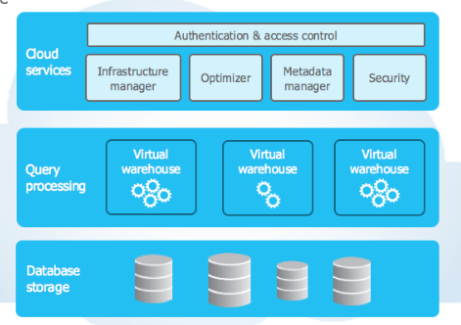

Database storage layer- DS-
- Stores table data and query results
- Data will be stored in columnar format
- Data will be stored in micro partitions
- Snowflake manages all aspects of how this data is stored i.e. the data organization, file size, structure, compression, metadata, statistics
- The data objects stored by Snowflake are not directly visible nor accessible by customers; they are only accessible through SQL query operations run using Snowflake.
- We can define cluster keys on large tables for better performance.

Query Processing Layer
- Query processing is the actual processing unit of snowflake and snowflake processes queries using “virtual warehouses”
- And also query processing layer will use the compute nodes through the virtual warehouses. and compute cost will be calculated on the basis of query execution time on virtual warehouses.
- We can do the scale up and scale OUT in this layer. Scale up is increasing the size of warehouse and scale out is the process increasing the number of clusters in warehouses.
- Auto-Suspend and Auto-Resume is also happening in this layer only.

Cloud- Services cs- cloud service-
- Cloud services layer has collection of services that organize the all activities across Snowflake.
- It will do the authentication and access control, metadata management and also security
- of the snowflake.
- Cloud service layer is handling the serverless tasks like snow pipe, M view management and task, Query parsing, optimization and access control etc.

What happens when we execute a query lo-
vwh (query processing layer) --> services layer --> verrifucation --> db layer (fetches data from db layer)--> execute --> optimized query plan --> service layer send query execution instruction to the VWH.

Connecting to Snowflake conn-
- Snowflake supports multiple ways of connecting to the service:
- A web-based user interface from which all aspects of managing and using Snowflake can be accessed.
- Command line clients (e.g. Snow SQL) which can also access all aspects of managing and using Snowflake.
- ODBC and JDBC drivers that can be used by other applications (e.g. Tableau) to connect to Snowflake.
- Through native connectors available in ETL tools (e.g. DataStage, Informatica)

Cluster Key- ckey- ck-
- Clustering is a key factor in query performance, It reduces the scanning of micro partitions.
- A clustering key is a subset of columns in a table that are explicitly used to co-locate the data in the table in the same micro-partitions.
- If we are creating the cluster on the small table, it performance of the table will degraded.
- To choose a clustering key we need the optimal low cardinality column (high duplicates)
- Initially the data will be stored in micro partitions in the order of inserting records, then will be realigned based on the cluster keys.
- We have to choose proper Cluster keys.
- It has to be created for a table having huge volume of data!
- We can define cluster keys on multiple columns as well.
- We can modify the cluster keys based on our requirements; this is called as re-clustering.
- Re-clustering consumes credits, number of credits consumed depends on the size of the table.
- If we able distribute the entire table data in the diff groups and eventually distribute it in the different groups then that column will give the better output while using that as clustering key!
- actually, snowflake will of the automatic clustering
- whenever the DML is happening to the table, that time, it will monitor the data and it will cluster the data
- if needed we can do the automatic clustering enable and disable by using of the
- Alter table command
- ALTER TABLE t1 SUSPEND RECLUSTER;
- ALTER TABLE t1 RESUME RECLUSTER;
- ALTER TABLE some_table_name CLUSTER BY (clustering_column_name);
- select *
- from table(information_schema.automatic_clustering_history(
- date_range_start=>dateadd(H, -12, current_timestamp)));

When to cluster
- Clustering is not for all tables
- Mainly very large tables of multiple terabytes can benefit

How to cluster
- Cluster keys had to be created for the columns that are used most frequently in WHERE clauses (often date columns for event tables)
- If we typically use filters on two columns then the table can also benefit from two cluster keys
- Column that is frequently used in Joins conditions.

Virtual warehouses vw-
- Each virtual warehouse is an MPP compute cluster composed of multiple compute nodes allocated by Snowflake from a cloud provider.
- Each virtual warehouse is an independent compute cluster that does not share compute resources with other virtual warehouses.
- As a result, each virtual warehouse has no impact on the performance of other virtual warehouses.

Real- what is the size of the virtual warehouses in your project?
I will consider the data volume and complexity as a factor
- We are using different size of virtual warehouse that differ based on the requirement and environment.
- For example: we are using L size for production environment and for testing environment, we are using S size.
- But in dev, we are using only XS size.
- SF admin team creates a specific VW for data loading (XS), a specific VW for processing queries (L) like user groups.

Virtual warehouse and its types and scaling policies
- one cluster can have multiple nodes.
- compute nodes will run the queries.
- one medium sized cluster can handle 16 queries at a given time.

The size of warehouse determines the number of servers in each cluster in the warehouse.

In AWS, ec2 servers are the compute nodes.
each warehouse contains different compute nodes.
sometimes, if the resources are not available to concurrently process all queries, then queries get queued for execution
and then gets executed as resources become available.

sf provides two options to increase the compute resources
1. Warehouse resizing (scale up)
2. multi-cluster warehouses. (scale out) - if there are many users, then we have to go with increasing
number of clusters because increase in number of jobs might increase queues for the queries to execute.
to avoid queues, we have to go with multi cluster warehouse.

why and when do you increase your number of clusters in warehouse?
we have so many jobs running concurrently in our system, that is why we go for increase in number of clusters.

java, python or scala then type is Snowpark optimized else standard.

There are two modes that is maximized and autoscale

- Maximized - then all the clusters will run parallelly at a time. (number of clusters always greater than 1) It is not recommended as it consumes many credits.

- Autoscale - when we run a query, how many min number of clusters(parallel) can be used and maximum also can be specified.

scaling policies
- It is applicable only when the warehouse running in autoscale mode.
- There are two scaling policies.
- Standard
- Economy

- Standard - Prevents/minimizes queuing by favoring starting additional clusters over conserving credits.
- Economy - Conserves credits by favoring keeping running clusters fully-loaded rather than starting additional clusters, which may result in queries being queued and taking longer to complete.

ALTER WAREHOUSE mywh SET SCALING_POLICY = 'ECONOMY';

Micro partition MP-
- Snowflake micro partitions are derived automatically and also micro partitions need not to be maintained manually, it will be managed by snowflake.
- Micro partitions are small in size (50 to 500 MB), which used to get the better performance in the DML operations and also faster selection of the data from the tables.
- Micro partitions are immutable.
- Micro partitions can overlap in their range of values which combined with their uniformly small size, helps prevent skew of data.
- Columns are stored independently within micro partitions, it is used to refer the data from columnar storage. Because of the micro partitions and columnar storage only we are getting huge performance while selection and DML operations in snowflake.
- Columns are also compressed individually within micro partitions. Snowflake automatically determines the most efficient algorithm for the columns in each micro-partition.

Sequence- seq-
- All values generated by a sequence are globally unique as long as the sign of the sequence does not change.
- Concurrent queries never observe the same value and values within a single query are always distinct
- Changing the sequence interval from positive to negative or vice versa may result in duplicates.
- Values generated by a sequence are guaranteed to be greater than the, maximum value produced by a previous statement.
- If the internal representation of a sequence's next value exceeds this range (in either direction) an error results and the query fails. Note this may result in loosing these sequence values.
- Many databases provide a currval sequence reference, however, snowflake does not have any currval to see the current sequence generated value.
- We can temporarily change the sequence in different order, use ALTER SEQUENCE ... SET INCREMENT to change the increment value.
- But it will not change the existing values which are created already.
- Also, we can go back to the original increment value, we can revert it back using ALTER SEQUENCE ... SET INCREMENT again.

File- formats ff-
- Snowflake supports 6 file formats with a lot of configurations.
- These file formats are used to translate the external file into tabular format data (parsing) as well as during copy command
- We can directly query external data without even creating an external table using file format.
- File formats are: csv, JSON, xml, Avro, orc, parquet
- We can use field optionally enclosed by option to overcome to single quotes in the data from file format.
- Null_if - is used to replace the null with the other values in file format.
- On _Error – is used to stop or continue when loading the data using the file format

Stage- creation in snowflake
- Snowflake does not allow any direct data loading to a table directly, so we have to create a stage object to load the data from the file to table. Loading of the data may be happen only from the stage location (internal or external).
- LIST @stage_name path – will give all files available in the list
- We can remove the files from the stage by using of the REMOVE command
- REMOVE @my_stage/path1/subpath2;
- We can select the columns from the staged files using the select $1,$2 from @stage_name.
- When we delete the files from the directory then, those files will get removed from the stage as well.

Types of stages
- Internal stage
- External Stage

- Stage is database object and not a table and represent a directory like place where all the data lands first before it gets loaded into table or further processing.
- AWS/ Azure/GCP can be mapped as external stage.
- Internal- stages store the files internally within Snowflake.
- External- stages store the files in an external location (e.g. S3 bucket) that is referenced by the stage.
- An external stage specifies location and credential information, if required, for the S3 bucket

Types of stages
- Internal stage
- External Stage

Internal stage
- Named stage
- User stage
- Table stage

Named stage
- Named stages are the database object and the named stages is used to load the data to any table and it can handle the privileges separately.
- Privileges can be granted to the named stages separately.
- We can create a named stages to load the data from the multiple files to the single table
- And also we can use the named stages to load the data to the same structured tables.
- CREATE OR REPLACE STAGE my_stage
FILE_FORMAT = my_csv_format;

User stage
- User stages cannot be used to set a file format options.
- User stages are referenced by @~ (AT Tilda)
- List @~ command is used to list the all user stages
- We can use the user stages to store the data files to access only by the respective user.

Table stage
- Each of the tables will be associated with the stage to store the data
- While creation of the table itself, tables stages internally will get created by the snowflake.
- And the table stages will have the same name of the table.
- Table stages cannot be altered or dropped.
- Table stages are not supported by the copy command.
- And also table stage is not a separate database object and it is implicitly associated with the table itself.

External Stage
- It is stored the files in the external location, like s3 location files can be accessed from the external stages.
- External stages allows the user to access the data from the external cloud like AWS, AZURE and GCP kind of cloud services.
- We can store the data in the external stage and from the external stage, we can use the copy into command to load the data to the snowflake database.
- It is protecting the data from the unauthorized access.
We can see the files available in the stage
We can also do tarnfromations in the stage
We can select fom the stage like select $1,$2,$3 from @stagename;

Integration- object int-
- Integration objects can be created by users which are having the accountadmin role.
- Integration objects are replacement of stage objects where stage objects are created using secret key
- For enterprise grade project, snowflake suggest to go with integration object with our cloud storage.
- Once integration objects are created, stage can use the integration objects to establish connection with cloud storage.
- Integration objects can be created and managed via sql command.
Integration object creation and handshake process with cloud storage varies from AWS to Azure to GCP.

Snow flake file to table file-

Process to flow
- We can keep the file in any of the directory in our system
- I will create the file format object which will refer the actual file format which we going to read it from the directory
- I will create the stage object in the snowflake database and that stage must refer the file format
- I will login the snowsql and I will use the put command to load the file data to the stage
- If the put command completes then, file is copied to the stage and then we can use the copy command to load the data from the stage object to physical table.

Commands

File format creation
Create or replace file format my_formattype = 'csv' field_delimiter =',';

Stage creation
CREATE OR REPLACE STAGE my_stage FILE_FORMAT = my format;

Put command in snowsql
PUT file://C:\Users\LENOVO\Desktop\Gobi\Emp_data.csv @my_stg;

Copy- command
- Copy command is used to read the data from the stage layer and it will load it into the snowflake tables.
- It is the fastest way to load the data from the stage to table, and also it will accept some basic level scalar transformation while loading the data.
- We cannot use the where clause in the copy command. Since copy command is reading the data from stage.

Stage
Copy into emp_load
From @my_stage/Emp_Data.txt
file_format =(type=csv);

Copy into emp_load
From @my_stage/Emp_Data.txt
FORCE=TRUE;

FORCE=TRUE will load the same data again from the stage to table
Without the FORCE=TRUE same data from the same file will not be loaded to the target

Copy options
- VALIDATION_MODE
- Validate the data files instead of loading them into the table
- RETURN_ERRORS gives all errors in the files
- RETURN_ALL_ERRORS gives all errors from previously loaded files if we have used ON_ERROR = CONTINUE
- RETURN_N_ROWS displays first N records and fails at the first error record
- RETURN_FAILED_ONLY
- Specifies whether to return only files that have failed to load in the statement result
- DEFAULT = FALSE
- ON_ERROR
- CONTINUE – To skip error records and load remaining records
- SKIP_FILE – To skip the files that contain errors
- SKIP_FILE_Num – Skip a file when the number of error rows found in the file is equal to or exceeds the specified number.
- SKIP_FILE_Num% – Skip a file when the percentage of error rows found in the file exceeds the specified percentage.
- Default is ABORT_STATEMENT, Abort the load operation if any error is found in a data file.
- FORCE
- Specifies to load all files, regardless of whether they’ve been loaded previously and have not changed since they were loaded
- Note that this option reloads files, potentially duplicating data in a table
- SIZE_LIMIT
- Specify maximum size (in bytes) of data loaded in that command (at least one file)
- When the threshold is exceeded, the COPY operation stops loading
- Threshold for each file
- DEFAULT: null (no size limit)

- TRUNCATECOLUMNS
- ENFORCE_LENGTH
- Specifies whether to truncate text strings that exceed the target column length
- TRUE = strings are automatically truncated to the target column length
- FALSE = COPY produces an error if a loaded string exceeds the target column length
- DEFAULT = FALSE
- PURGE
- specifies whether to remove the data files from the stage automatically after the data is loaded successfully
- DEFAULT: FALSE
- LOAD_UNCERTAIN_FILES
- specifies to load files for which the load status is unknown. The COPY command skips these files by default.
Note: The load status is unknown if all of the following conditions are true:
•The file’s LAST_MODIFIED date is older than 64 days.
•The initial set of data was loaded into the table more than 64 days earlier.
•If the file was already loaded successfully into the table, this event occurred more than 64 days earlier.

Copy Real-time Usage
- ETL Source files can be loaded to the stage tables and then we can do the transformations on the stage table instead of doing the transformations on the files.
- Any format of the files can be loaded to the stage, so there is no limitation on the file types and also the fastest data loading method and also it supports the huge data as well.
- Same method supports the AWS, AZURE and GCP clouds, so that we can follow the same process to read the data from the cloud storage and we can move the data to the snowflake warehouse.

AWS s3 to snowflake data load (Snow flake file to table ctd.. )

Steps
- Create a table to accept the data from the s3
- Create a file in the s3 bucket
- Create the Role and give the permissions and create the trusted policy
- Create the storage integration in snowflake
- Create the stage in snowflake
- Run the copy command to load the data

Commands

Create the storage integration in snowflake
- Create or replace storage integration aws_storage
Type = external_stage
storage_provider = s3
storage_aws_role_arn = ‘arn:aws:iam::759489707541:role/AWS_S3_INTEGRATION'
enabled = true
storage_allowed_locations = ('s3://aimore-snowflake-s3/EMP01/');
Red highlighted number is the ARN number that must be pasted from the AWS
Green Highlighted id is the allowed locations, this has to be copied from the s3

Real time Usage copy real
- ETL Source files can be loaded to the stage tables and then we can do the transformations on the stage table instead of doing the transformations on the files which are from the cloud.
- Any format of the files can be loaded to the stage, so there is no limitation on the file types and also the fastest data loading method and also it supports the huge data as well.
- Same method is supports the AWS, AZURE and GCP clouds, so that we can follow the same process to read the data from the cloud storage and we can move the data to the snowflake warehouse.

Snow Pipe-
- Snow-pipe (a server less data ingestion service)
- Snow-pipe is automate the data loading from the cloud storage like AWS, AZURE and GCP
- Snow-pipe is the process of wrapping the copy command and it enables the automatic data load from the files using the event notification.
- We wil use auot ingest option as true for continuous load
- If we load the file in the cloud, automatically it will read the data from the file and it will load the data.
- It works like a file watcher and it automate the ETL process.
- There is a size limit for files while data into snow pipe (upto 250MB)

Commands

File format creation
Create or replace file format my_formattype = 'csv' field_delimiter =',';

Stage creation
CREATE OR REPLACE STAGE my_stage FILE_FORMAT = my format;

Put command in snowsql
PUT file://C:\Users\LENOVO\Desktop\Gobi\Emp_data.csv @my_stg;

Copy command in snow sight copy
Copy into emp_load
From @my_stage/Emp_Data.txt
file_format = (type=csv);

Copy into emp_load
From @my_stage/Emp_Data.txt
FORCE=TRUE;

FORCE=TRUE will load the same data again from the stage to table
Without the FORCE=TRUE same data from the same file will not be loaded to the target

Pipe load- pload- pl-
BETWEEN THE S3 AND SNWOFLAKE
- Once integration object has been done by sf admin team
- And then we have to create the file format
- And then we will create the external stage
- And then we can use the copy command with proper copy options.
- And then we can use the pipe to read the data in the continuous data integration
- We can run the copy command to load the data from the directory to table load.
- Additionally, we can create the pipe object to read the data from the AWS in the continuous manner and upload the data to the snowflake table.
- To create the pipe object, we have to create the snow pipe using the create pipe command
ALONG WITH AUTO INGEST IS equal TO TRUE for continuous load.
- We also use SQS notification to notify the pipe whenever the file is uploaded in the s3.
So, it will notify the pipe directly.
- create pipe mypipe_s3
auto_ingest = true
aws_sns_topic = 'arn:aws:sns:us-west-2:001234567890:s3_mybucket'
as
Copy into snowpipe_db.public.mytable
From @snowpipe_db.public.mystage
file_format = (type = 'JSON');

Snow Pipe- Extra contents
- To achieve the snow pipe from the aws cloud we have to keep the files in the s3 and then we have to create the storage integration to integrate the ARN from the AWS with the snowflake and also and also s3 bucket accept path with the snowflake
- Then we need to create the pipe object in Snowflake
- Execute the show pipes command and see the output column called the notification channel
- Copy the value of notification channel
- And then we can create the file format and then we can create the stage
- Open the s3 bucket and select it and see the properties tab and go down and see the event notification
- Use Create button to create the new event notification and give any of the event name!
- Details and step by step configuration of snow pipe, please refer the below document

Auto Ingest- ai- ing-
- The auto-ingest feature relies on SQS queues to deliver event notifications from S3 to Snow pipe.
- Snow pipe SQS queues are created and managed by Snowflake.
- The SHOW PIPES command output displays the Amazon Resource Name ARN of SQS queue.
- This Snowflake ARN has to be added in the amazon role's trusted policy!
- Also, we have to provide the ARN Id from the AWS while creation of the storage integration object creation in snowflake DB.
- So, whenever a file comes to the s3, it will notfy the pipe.

Validation
- After completion of the auto ingest, we will do checks as
- Pipe status checking to check any error or warnings is happens to the pipe execution or not
- To check the pipe error,
SELECT SYSTEM$PIPE_STATUS('<pipe_name>');
- After that we have to check the data which are loaded by the pipe!
- data quality validation such as data ranges which are loaded
and the start data and end data loaded by the pipe!
- Duplicate data loaded by the pipe or not
- Number of rows loaded by the last execution
- Number of rows before the load and after the load
- Number of rows in the file and table
- Number of files newly added in the directory
These validations we can do, after completion of the auto_ingest!

Snow pipe Error Notifications Err- ERROR- pipe er-
- Snow pipe error notifications only work when the ON_ERROR copy option is set to SKIP_FILE (the default).
- Snow pipe will not send any error notifications if the ON_ERROR copy option is set to CONTINUE.
- We can use the NOTIFICATION_HISTORY table function to query the history of notifications sent through Snow pipe.
- We can use the table function to see the notification history details in snowflake
- select * from table(information_schema.notification_history(
START_TIME=>dateadd('hour',-1,current_timestamp()),
END_TIME=>current_timestamp(),
RESULT_LIMIT=>100,
INTEGRATION_NAME=>'MY_INTEGRATION'));
- We can use the table function, ’ PIPE_USAGE_HISTORY’ to see history of data loaded into Snowflake tables using Snow pipe within a specified date range. This function returns pipe activity within the last 14 days.
- Syntax : PIPE_USAGE_HISTORY([ DATE_RANGE_START => <constant_expr> ]
[, DATE_RANGE_END => <constant_expr> ]
[, PIPE_NAME => '<string>' ] ).
- select * from table(information_schema.pipe_usage_history(
date_range_start=>dateadd('day',-14,current_date()),
date_range_end=>current_date(),
pipe_name=>'mydb.public.mypipe'));

pipe refresh

File available in the AWS but data not loaded to the table ts- shoot-
- I will ensure the necessary permissions have been provided for the s3 bucket.
- I will refresh the pipe first and check whether the data got loaded to the external stage.
- If the data is not available in the external stage, then I will check for the integration between the SF account and s3 bucket. We have separate AWS team who usually checks ARN related integrations and ensure the trust policy has been updated in the IAM role.
- If all fine, Will check for the data in the external stage. If data is available in the external stage but not loaded to the table, then I will check the copy command that has been used to load the data from S3.
- I will check if the command has the correct stage, file format, and file type.
- I will check if the file format in the SF acc matches with the file format in the S3.
- I will also check the COPY_HISTORY table function from the INFORMATION_SCHEMA to retrieve historical information about COPY commands where I will check details about copy command like status, error messages, and other relevant information. Based on the error codes or messages, I will resolve the issue.

Is there any size limit for file loading in snow pipe- pipe limitation-
- The recommended file size for data loading is 100-250MB compressed,
- However, if data is arriving continuously, then try to stage the data within one-minute intervals.
- An optimal size between 10-100MB compressed may be a good balance when loading through Snow pipe.

Pipe real-
- In my project, We have created the pipe object to read the data from the added files in the aws s3
- One trade having the multiple payments so that payment files will be received from aws s3.
- Daily basis payment files will be added in the s3 bucket directory.
- Our pipe operation read the data from the payment file and it will added to the table through the external stage.
- For this payment file load and the settlement file load, we are using the snow pipe with the auto ingest mechanism that is for continuous loading!

Loading types- Load-
- Bulk loading using Copy
- Continuous loading using Snow pipe

Bulk Loading Using the COPY Command
- Bulk Load will load the data in the single shot.
- If any of the new file copied in the same directory then bulk load will not load the data automatically.
- We need to create the storage integration object to extract the data from the cloud storage.
- We can use the bulk load for the full data load and the single time load.
- Bulk load can be used for the internal stage as well.
- Bulk load will use the warehouse size, if the file size is huge then, we have to increase the warehouse size while doing the bulk load.

Continuous Loading Using Snow pipe cont-
- Continuous data load will add the data in the frequent manner and it will load the data in the small chunks. Continuous load can be loading the data in the increment manner.
- If we are adding the new files in the same directory, that will be accepted and those data will be added in the table while using the continuous load.
- we have to use the auto_ingest as TRUE option to enable the continuous load and also we can use the continuous load in the snow pipe.
- Snow pipe loads data within minutes after files are added to a stage and submitted for ingestion.
- The COPY statement in the pipe definition supports the same COPY transformation options as when bulk loading data.

Other ways to load Data to snowflake
We have to use the any of the ETL tools to load the data to the snow flake. For example,
- Matellion
- Datastage
- Informatica
- Hevo
- Azure Data Factory
- Azure Synapse etc

Simple Transformations During Data Load trans- loadtrans- ltran-
Snowflake supports transforming data while loading it into a table using the COPY command. Options include:
- Column reordering
- Column omission
- String operations
- Other functions
- Sequence numbers
- Auto increment fields

Steps to load the data to snowflake aws- snowflake data
- First, we have to keep our data source file in the s3 directory and we need to allot the necessary permission through the IAM user access (Identity Access Manager)
- We have to create the storage integration object in the Snowflake by using of the create storage integration object command.
- Create the Role in AWS and give the permissions and create the trusted policy
- While creation of the storage integration object we have to provide
- Type as external state and we have to mention the s3 as storage provider parameter and then we have to provide the ARN number (Amazon Resource Names) from the AWS that we have to mention the
- Storage_aws_role_arn parameter and then enabled status as True and the storage_allowed_locations as s3 file directory these things will used to access the AWS location from the snowflake!
- Create or replace storage integration aws_storage
Type = external stage
Storage_provider = s3
storage_aws_role_arn = ‘arn: aws:iam:: 759489707541:role/AWS_S3_INTEGRATION'
Enabled = true
storage_allowed_locations = ('s3://aimore-snowflake-s3/EMP01/');
- After creation of the storage integration, we can describe the storage integration object from the snowflake and we can pick the storage_aws_Iam_user_arn from the snowflake and then we have to paste in the trusted policy of the roles we have to update it, so that snowflake will reach the aws cloud.
- create pipe mypipe_s3
auto_ingest = true
aws_sns_topic = 'arn:aws:sns:us-west-2:001234567890:s3_mybucket'
as
Copy into snowpipe_db.public.mytable
From @snowpipe_db.public.mystage
file_format = (type = 'JSON');
Here we have to mention the auto_ingest parameter as true – to enable continues data loading and then we can mention sqs name if we need to enable the notifications else we can skip the SS and we can give the copy command directly. It is just wrapping the copy command we can enable continues data loading to the table.
- Now I will execute the show pipes command and see the output column called the notification channel
- Copy the value of notification channel
- Open the s3 bucket and select it and see the properties tab and go down and see the event notification
- We can use Create button to create the new event notification and give any of the event name!
- WE WILL CREATE TASK WITH GET EXECUTED FOR EVERY MONTH AND BASED ON THAT, WE WILL TAKE THE UPDSTED THE RECORD CONUTIONUS MANNER.
- IF ANY LOAGICS NEEDED, WE WIL CREAT ETHE PROEDURE.
- NOT THAT MUCH
- I SCHELDED WITH HOURS AND MINUSTES

Snow stream- Object st-
- Stream object is taking the snapshot of the DML operation,
- it takes the snapshot of the old data which are changed in the DML operations and it can be used to the CDC (Change data capture) .
- I SAID IT IS USED TO HOLD THE HISTORICAL DATA
- This is not the physical data capture, it is the logical data capture,
- It stores the offset of the data so that stream object can accommodate very less storage.
- So stream itself does not contain any table data.
- We can create more than one stream object on the same table.
- If we drop and recreate the base object or else create or replace of the base object in the same name will makes the stream object on stale status and further that stream will not consume the data.
- Stream can be created on view but cannot be created on m views.
- Always the stream object must be on the stale status as false. Else it will not capture the data
- To find the stale status of the stream we can use the DESCRIBE STREAM employee_stream;
- If we are updating the same value then that time stream will not updated, since none of the data has been changed in the base object by the update statement.
- For example col1 is having the data as A in the all rows, if we updating the same column using the update statement with A then
- Update table set col1 = ‘A’ then, all rows are updated in the same value, but no changes in the data of the base table. So stream no need to capture the data of CDC
- If we are copy the data from the stream to any other table, stream object will lose the data since stream are not stored the data directly and it showing us data through micro partitions.
- It captures only the last DML operation with respective to the row.
- If we updating the employee id 100 ‘s row then that will be captured by the stream and then of we remove the row employee id as 100 then it will lose updated audit data and it will keep only the last action as deleted audit data in the stream.
Ex
- Create table emp_load as select * from employees;
10 rows loaded to the physical emp_load table
- Create or replace stream emp_stream on table emp_load;
Stream object has been created on the emp_load table
- Delete from emp_load where employee_id>100;
Some rows from emp_load has been deleted and those rows are captured by emp_stream object. Now we can see the deleted rows from the stream object emp_stream.
- Create table t1 as select * from emp_stream;
Based on the deleted data we are creating the new table! So the data physically created to the t1 table. Now stream object will not have the data.
Note
In each time stream data has to be loaded to the audit table properly, then only we can capture all of the changes through the stream!
If we are not taking move the data to the audit table from the stream object then, offsets will not move to the next position so that we can see only the first and last changes of respective rows.

Steps
- Create a table t1
- Create a stream object s1 on table t1
- Create an audit table a1 to capture the changes on t1
- Insert into t1 values (10)
- Select the stream object, we can see the data in the t1 and the s1
- Select the data from the s1 and load to a1
- Update the t1 to change the 10 as 20
- Select the stream object, we can see the data 10 with delete flag and 20 with insert flag
- Select the stream s1 and load the data to the a1 (after load the data to a1, s1 became empty)

Types
- Standard Captures all DML operations and also truncate
- Append_only Captures only update statements
- Insert_Only captures only inserts and also this is the only type can accommodate with external tables

Commands
Create or replace stream employee_stream on table employees;
Create or replace stream employee_stream on table employees append_only =True; Captures only the updates
Show Streams; will display all streams available in the user.
Select * from employee_stream;
Meta data columns are available on the stream object for the audit purpose
- METADATA$ACTION
Indicates the DML operation (INSERT, DELETE) recorded.
- METADATA$ISUPDATE
Indicates whether the operation was part of an UPDATE statement. Updates to rows in the source object are represented as a pair of DELETE and INSERT records in the stream with a metadata column METADATA$ISUPDATE values set to TRUE.
Streams record the differences between two offsets. If a row is added and then updated in the current offset, the delta change is a new row.
The METADATA$ISUPDATE row records a FALSE value.
- METADATA$ROW_ID
Specifies the unique and immutable ID for the row, which can be used to track changes to specific rows over time.
DESCRIBE STREAM employee_stream;
Will give the details about the stream object like creation time, base object name, stale status and other details.
Stale status on streams
Stream reached the stale status then, stream will not capture any data.
Stale status of the stream is based on data retention period on the snowflake edition which we configured. By default it will be as 14 days.

Stream real-
- In our project, we used stream object in our landing layer to capture all the changes in our Dm_customer table, dm_branch tables, dm_currency, dm_legal_party tables.
- If any changes are being made in these source tables which is got loaded from the multiple sources like oracle and files. We have Using stream to track all the changes which are made in the table
- This is how we maintained the historical data and loaded to the dimension table in the curated zone using the task.

Snowflake Table- types tt- ttype-
- Permanent Table
- Transient Table
- Temporary Table
- External Table

Permanent Table perm- pt-
- These are the standard, regular database tables.
- Permanent tables are the default table type in Snowflake.
- The default time travel period for permanent table is 1 day and max retention period is 90 days.
- Create table employee (empid number, name varchar2(50));

Transient Table trans- tt-
- Transient tables in Snowflake are similar to permanent tables except that that they do not have a Fail-safe period and only have a very limited Time Travel period.
- That is 1 day only we can do time travel with the transient table.
- Transient tables can be used for the staging purpose, since the staging tables data is not required any fail safe and also the time travel
- Transient table cannot be cloned, since it will have only one day as max time travel period and also it is not have the fail safe data, so that clone operation cannot access the data for the transient table.

What are the Restrictions for Snowflake Transient Tables?
- It is not possible to name a Temporary Table the same as a Permanent Table.
- Some basic features, such as Cloning, are not supported by Temporary Tables.
- After the Time Travel retention term expires, the data in the Transitory Tables cannot be restored.
- There is no fail-safe timeframe for Transient Tables.
Create transient table student (regno number, studentname varchar(50));

Temporary Table temp-
- Snowflake supports creating temporary tables to store session based data
- Temporary tables exist only within the session.
- They are created and persist only for the session remainder.
- They are not visible (tables and data both) to other sessions and also it is not supports to do the cloning.
- Temporary tables are automatically dropped when the session has been closed.
Create temporary table Supermarket (Phono number, BatchName varchar (50));
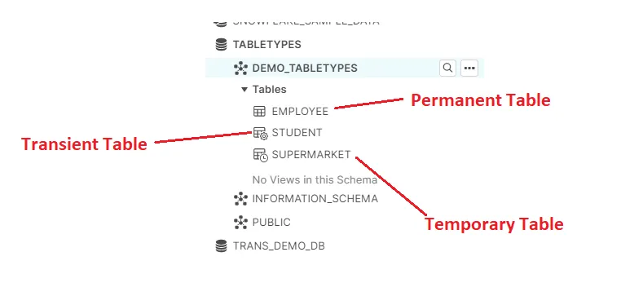

External Table ext- et-
- Snowflake external tables provide a way to query multiple files by joining them into a single table.
- Snowflake External tables allow you to query the files stored in external stage like a regular table, that means without moving that data from files to Snowflake tables.
- External tables access the files stored in external stage area such as Amazon S3, GCP bucket, or Azure blob storage.
- External tables store metadata about these data files, such as value (complete record), the filename and file row number.
- External tables are read-only, therefore no DML operations can be performed on them.
- But we can use external tables for query and join operations.
- Views and Materialized views can be created against external tables.
- Querying data from external tables is likely slower than querying database tables.
- Advantage of external table is you can analyze the data without storing it in Snowflake.

Metadata of External tables
- External tables store below metadata information.
- VALUE: A VARIANT type column that represents a single row in the external file.
- METADATA$FILENAME: A pseudo column that identifies the name of each staged data file included in the external table, including its path in the stage.
- METADATA$FILE_ROW_NUMBER: A pseudo column that shows the row number for each record in a staged data file.

Creating External Tables
For creating External tables,
- First, we have to create file format object
- And then we will create stage object referring to cloud storage location.
- Finally, we have to create the External table to see the file data from the cloud.
If there are multiple files of same pattern, we can just create one External table and it can store the details of all similar files.

Refreshing External Tables
- External tables will be refreshed automatically.
- And it will sync the files and data with the external table like,
- if any new files are added in the directory, then those will be added in the external table
- Also, Updated data from the existing files also will be updated in the external table data selection.
- Also, if any of the files are removed from directory then, those data also will get removed from the external tables data output.
Example:
CREATE OR REPLACE EXTERNAL TABLE SAMPLE_EXT
(ID INT AS (VALUE:C1::INT),
NAME VARCHAR(20) AS ( VALUE:C2::VARCHAR),
DEPT INT AS (VALUE:C3::INT)
)
WITH LOCATION = @MYS3STAGE
FILE_FORMAT = MYS3CSV;

Dynamic tables Dt-
- Dynamic tables are having the feature of auto accommodate data from the source table in the respective interval.
- We can create a dynamic table with target lag option, based on the target lag option automatically it will check the base table and it will consume the data from the source.
- Create or replace dynamic table Tab_001
Target lag =’1 MINUTE’
Warehouse= COMPUTE_WH
AS
Select * from EMP;

Directory Tables dir- Directory- direct-

- It is not a separate DB object.
- It has metadata of the files in the stage.
- It can be enabled while creation of the stage or using alter statement.
- It has to be manually refreshed to get the updated records.
- When it comes to external stage, notification can be enabled just like snowpipe.

Synatax

[ DIRECTORY = ( ENABLE = { TRUE | FALSE }
[ REFRESH_ON_CREATE = { TRUE | FALSE } ] ) ]

Hybrid Tables hybrid- ht-
Hybrid tables provide fast single-row operations and analytic-like performance on transactional data.
Constraints like primary key and unique key can be created and enforced on a table.

Limitations of hybrid tables
- Recommended maximum is 100GB.
- Should not exceed 100 QPS.
- Not ideal for large range scans or complex analytics.
- Certain features like cloning, materialized views, streams, replication, and data sharing are not supported.

Iceberg tables ice- iceberg-
--need to check and stduy compeltely
Iceberg tables in Snowflake offer a compelling solution for organizations grappling with large-scale data management that necessitates both open standards and powerful performance. This innovative feature combines the best of both worlds:

Openness and Flexibility:

Built on Apache Iceberg, an open-source table format, ensuring vendor neutrality and interoperability with various tools and ecosystems.
Stores data in your preferred cloud storage (e.g., AWS S3, Azure Blob Storage) for enhanced control and cost optimization.
Snowflake Performance and Familiarity:

Leverages Snowflake's advanced query engine and familiar SQL syntax for seamless integration into your existing workflows.
Supports expressive SQL commands (e.g., updates, merges, deletes) for effective data manipulation.
Key Benefits:

Cost Efficiency: Store data outside Snowflake while enjoying its performance and ease of use, potentially reducing storage costs.
Governance and Compliance: Adhere to specific data governance or compliance requirements that necessitate open formats.
Unified Management: Option to use Snowflake as the Iceberg catalog for centralized metadata management and lifecycle operations like compaction.
External Catalog Integration: Connect to existing Iceberg tables stored in your cloud storage using external catalogs like AWS Glue.
Considerations:

Limited Features in Preview: While offering core functionalities, some advanced Snowflake features might not be available in the current public preview.
Potential Complexity: Managing Snowflake as the Iceberg catalog or integrating with external catalogs adds some complexity compared to native Snowflake tables.
When to Consider Iceberg Tables:

You have large datasets that necessitate open formats and cloud storage management.
You want to leverage Snowflake's performance and SQL capabilities while maintaining data flexibility.
You already have an existing Iceberg data lake and want to integrate it with Snowflake seamlessly.

Dup- duplicate-
- We can select the duplicate data using the group by and having clause
- And also we can select the duplicate data using the window function ROW_NUMBER and partition by clause
- Select Empid from emp group by Empid having count(Empid) >1 ;
- By using of analytical function
Select * from
(
Select Empid, row_number () over (partition by Empid order by Empid) r1 from emp
)
Where r1 >1;
- But to remove the duplicates from the table we have to use the SWAP or overwrite command in snowflake.

Fcache-

We can use swap command
- Swap command is used to swap the data between the two tables
- Alter table command can be used to swap the data between the tables
- We can use the swap command to remove the duplicates in the table.
- We wil create the ne wtable and we wil swap between them
- We can select the distinct data using the distinct selection and the data can be created as table.
- And then we can swap the data with the original table.
- Duplicate removal using the swap
- Create table emp1 like emp; -- table will be created without data.
- Insert into emp1 Select distinct empid, ename from emp; --distinct data will be loaded to the emp1 table
- ALTER TABLE emp SWAP WITH emp1;
- After execution of the swap data will be interchanged between the both tables

OVERWRITE-
Overwrite is used to replace the data from the source table.
After execution of the overwrite, both tables will have the same data.
INSERT OVERWRITE INTO tabelanme SELECT distinct * FROM tabelanme

Time Travel Un-drop Clone

Time- Travel-
- Snowflake Time Travel enables accessing historical data
- if the data has been changed or deleted those can be accessed then we can use the time travel to lookback the changes of the data in the last 90 days.
- We can do the time travel in the 3 different ways like , using the offset, using the statement_id, and also using the timestamp.
- Offset is calculated based on the seconds.
- DATA_RETENTION_TIME_IN_DAYS is the table level setup that is used to set the time travel duration
- DATA_RETENTION_TIME_IN_DAYS =1 is the default value for all type tables
- We can change or limit the time travel days by using of the parameter as data_retention_time_in_days =3 ; we can change the retention time of the table while creation of the table or the alter table command
- Example
Create or replace table tt_3_days
(Empid number, ename varchar2 (200))
data_retention_time_in_days =3;

Alter table tt_3_days set data_retention_time_in_days =5;
- 90 is the maximum time travel days, we cannot give more than 90 as retention period.
- Time travel using seconds : select * from tt_3_Days at (offset => -60); data 60 seconds ago
- Time travel using sql_id : select * from tt_3_days before (statement=> '01af05ec-3200-e019-0005-eb420004d12e')
- Time Travel using Timestamp : select * from t1 At (Timestamp => cast('2023-11-13 21:01:24.408 -0800' as timestamp_tz));
- or
- select * from t1 Before (Timestamp => '2023-11-13 21:01:24.408 -0800' :: timestamp_tz);
- alter table tt_3_days set data_retention_time_in_days =5 ;
- deleted data and also the truncated data can be recovered using the time travel

fail safe safe- fail-
- It is non-configurable 7-day period for permanent tables and there is no fail safe period for transient and temporary tables.
- It can be done only by sf admin team.
- No user interaction & recoverable only by Snowflake
- Period starts immediately after Time Travel period ends
- Contributes to storage cost

When can be used time travel
- I have used time travel to retrieve the data which are deleted from the old tables.
- For example, I have performed the time travel to retrieve the data which are updated and deleted and I have compared the data with the current table.
- And then I have identified and validated the data which are the modified in the certain time period.
- I USED IT WHEN DEVELOPING THE NEW REQUIREMNT AND I USED OFFSET WHEN I DELTE DTHE DATA FEW HOURS BEFORE

For Transient tables
- For transient tables, data_retention_time_in_days =1 this is the max limit allowed for data retention.
- If we give more than 1 in this parameter it will not get created will throw the error while creation of the table.

For Temporary tables
- For temporary tables by default 1 day is the retention period
- If we give more than 1 in the parameter (data_retention_time_in_days =2) temp tables accept this and it will get created and if we see the show tables command we can check the retention time, it will be 1 , this taken by default while creation and ignores our value which provided in the creation of table.
Show tables like '%ttt_days_tmp%';

Undrop-
Undrop is used to recover the dropped table with data based on the data retention period
Drop table tt_tab1_undrop;
Undrop table tt_tab1_undrop;

TO RESTORE DATA USING TIME TRAVEL:
Step1:
create or replace table t1_bkp
as
select * from t1
Before(statement => '01b0510c-3200-ef1e-0006-b7da0006b142');

Method 1 : (Overwrite)
insert overwrite into t1
select * from t1_bkp;

Method2 (swap)
alter table t1 swap with t1_bkp;

delete table- deletetbl- dtbl-
- We can find the deleted tables by using of the information_Schema.tables and in that view we can see the column as is_Deleted shows the table is available or deleted.
- After finding the deleted table we can see who is deleted the table and the time details we have to check in the QUERY_HISTORY view from account_usage schema from snowflake database

SELECT start_time, query_id, query_text, user_name
FROM snowflake.account_usage.query_history
WHERE query_text ILIKE '%DROP TABLE%<tablename>%';

Clone-zero copy clone- zero cost clone- zc- 0-
- Clone option is used to create a backup table and it is taking the copy of the data while execution of clone command it will not copy any history from the old table
- Clone is a ZERO COPY clone, it will not occupy the storage, so it will not take any cost.
- For example, retention data will not copied from the old table to the new one.
- Clone is the pointing time snapshot of the existing table.
- Create Backup table using the create statement as below will create the physical table and it will copy the entire data from the old table to the new table and it will occupy the storage for the copied data.
- Create table emp_old as select * from EMP;
- We can use the below sql to identify to unused active bytes of table while using the clone operation.
- Cloning will not occupy any new storage so zero cost used for storage and it is used some resources for the cloning operation that may use some cost, that is very less.
DML- on Clone table- DC-
- After cloning the table, source table and the clone table will become the independent objects.
- It will not be affected the cloned object and new
- If we are doing any DML operation on the clone table, that data will occupy the storage so, those new data will occupy the micro partitions.
- We will clone while doing unit testing and also sometimes we do SIT testing, that time also we will clone table and other objects

- Select * from SNOWFLAKE.ACCOUNT_USAGE.TABLE_STORAGE_METRICS WHERE TABLE_NAME IN ('CT_NEW','CT_OLD');
No | Source_Table_type | Target_Table_type | Cloning possibility
1 | Permanent | Permanent | Yes
2 | Permanent | Temporary | Yes
3 | Permanent | Transient | Yes
4 | Temporary | Temporary | Yes
5 | Transient | Temporary | Yes
6 | Temporary | Transient | Yes
7 | Transient | Transient | Yes
8 | Temporary | Permanent | No
9 | Transient | Permanent | No

Cannot be cloned- No clone-
- External tables cannot be cloned
- Internal stages cannot be cloned

Clone table (objects) vs clone DB dbclone- clonedb-
- Objects cloning will clone the grants and also the roles.
- But DB clones will not clone the grants and roles.
- CREATE DATABASE my_cloned_db CLONE my_original_db;
- CREATE table db.schema.table CLONE old_db.schema.table;
- Internal stages and external tables cannot be cloned by db clone.

Task-
- Task is used to schedule the particular task in the snowflake database
- It will accept only one sql statement at the time
- If we need to execute multiple statement in the single task then, we have to put all into a single procedure and that procedure has to be called in the task.
- Task tree is working like box jobs.
- We can create dependent jobs under a parent job and those jobs will start execution in the serial order.
- After creation of the task tree, we have to suspend all tasks and then we have to resume tasks from the child first and root last order.
- Root Task Creation
Create or replace task my_task
Warehouse = compute_wh
Schedule = ‘1 minute’
As
Insert into emp_data ();
- Child task creation
Create or replace task my_child_task
Warehouse = compute_wh
After my_task
As
Insert into emp_data_audit ();

- After keyword has to be used while creation of the child task and the child task cannot have the Schedule keyword, since it is running after completion of the root task, so that schedule parameter is not needed to creation of the child task.

…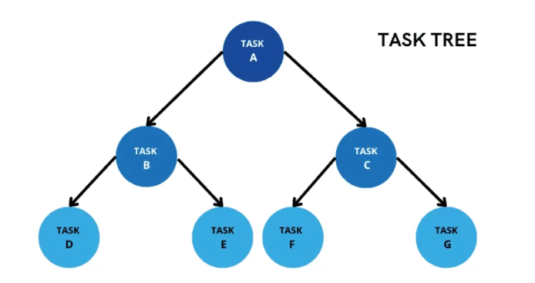
- Here task A is the root task and all others are child tasks, we can suspend the tasks by using suspend command.
- After creation of the task tree, we have to suspend all tasks and then we have to resume tasks from the child first and root last order.
- Alte rcommand has to wrotetn ten time
- All tasks must be in the started state.
- Parent task is the root task and child task cannot be created or replaced when the parent is active. In this case we have to suspend the parent task and recreate the child task and then we have to resume the child task first and then resume the parent task.
- show tasks
Show tasks will show all tasks which are available and also, we can use the like operation with the task name to see the specific tasks.
- use role accountadmin;
We have to use the role accountadmin to resume the tasks

Alter task dept_task01 resume;
Alter task dept_task01 suspend;

- To Check the job completion status
SELECT query_text, completed_time
FROM snowflake.account_usage.task_history

- To Check the job error messages and execution details
Select *
From Table (Information_Schema.Task_History ())

- To perform the task when the stream receiving the data, we have to use the when clause to check the stream data status

CREATE OR REPLACE TASK my_streamtask
WAREHOUSE = COMPUTE_WH
SCHEDULE = '5 minute'
WHEN
SYSTEM$STREAM_HAS_DATA ('my_stream')
AS
INSERT INTO EMPLOYEE (id, name, salary) SELECT id, name, salary FROM my_stream WHERE metadata$action = 'INSERT' AND metadata$isupdate = 'FALSE';

Task can be executed externally by using the EXECUTE command
EXECUTE TASK my_task;

Task real-
- In our project, we have scheduled the loads using task.
- We have created logics using procedures for payment, settlement and account setup based on the business rules like
- for example, customer wise number of trades,
- Number of trades in the branch wise kind of aggregate transformations and called the procedures inside the task by scheduling it.
- When the data got loaded to the dimension tables, we scheduled it to load to the fact tables.
WE CAN CERATE THE TASK OVER A STREAM

Limitations of task
- If you try to have more than one SQL statement, task creation will end with error:
- And if need to execute more than one sql statement in the task we have to create that as procedure and we can call the procedure using the call command.
Schedule parameter only takes minutes, it does not support second or hour.
- The minimum value is 1 min and you cannot go below this number.
Once task is created, it is in suspended state.
- Just because we have created a task, does not mean that it will start automatically
- Each task has a unique task id, owner, warehouse, schedule, predecessor, definition,
condition (applicable for stream and we will see it later) allow overlap (we will see it later)
- To resume/suspend a task, we need task execute grant

Compute WH-
Compute costs represent credits used for: Virtual Warehouse compute — Virtual warehouses consume credits as they execute queries, load data and perform other DML operations.

Compute cost and storage cost

View- Views-
- Views are used to displaying certain rows and columns in one or more tables.
- It executes the sql which is stored behind the view, so that it will take time to execute the sql.
- Views are used to share data to the partner application.
- If we are granting the table from one schema to another then, entire column of the table will be visible to the another schema! In that case if we are creating as view to select the required columns and we can share only the respective columns to the other schema.

Normal View-
- A View is a database object that contains SQL query built over one or multiple tables.
- A View can be considered as a virtual table that can be used almost anywhere that a table can be used (filters, joins, subqueries, etc.).
- Whenever you query a view, the underlying SQL query associated with the view gets executed dynamically and will fetch data from underlying tables.
- Views serve a variety of purposes like combining, segregating and protecting data.

Secure views secure-
- A Secure View does not allow users to see the definition of the view.
- Users can’t see the underlying sql query.
- It will not be optimized by cloud service layer.
- The definition of a secure view is only exposed to authorized users i.e. users who have been granted the role that owns the view.
- Only once , I have created the secure view for payment information
- 2 Advantages of secure views
  - Can protect the data by not exposing to other users.
  - I don’t want the users to see underlying tables present in our database.
- IS_SECURE column in the Information_Schema and Account_Usage tells us a view is secure or not.

M-view- mw-
- it will occupy the space
- and it will take the copy of the data from the table
- In one view, we can use only one table.
- If we need to join multiple tables in the materialized view then, it will not support it.
- A materialized view stores pre-computed result set and it have the own data .
- Querying a materialized view gives better performance than querying the base tables.
- M view can create on a single table, can’t build on multiple tables.
- M-View mainly used to improve the query performance when we are using same dataset repeatedly.

Refresh of M-views
- No need to refresh the data manually.
- Snowflake performs automatic background maintenance of materialized views.
- When a base table changes, Snowflake runs a background process to keep the materialized views up-to-date, but takes a minute to refresh.

When to create M views- real-
- We can create a materialized view when the query results are not changed frequently and also the sql consumes lot of resources to executed it then we can create that as M-view,
- Say for example, if we are doing the aggregation on the huge data then that will take more time and also it will take more processing resources, in that case we can create that as M-view.

M-View Limitations-
- We cannot join multiple tables and also it will not support the self joins
- We cannot do the order by and also, we cannot use the having clause in materialized views.
- We cannot select the data from stream object as a source of view or the materialized views.
- If we drop the base table after creation of the materialized view then, M-view will become invalid status, in that case we need to un-drop the table to make the M-View as valid status again.

Advantages of Mviews
- Improves the performance
- No need of additional maintenance, auto refresh of results
- Data accessed through materialized views is always current, regardless of the amount of DML that has been performed on the base table.

When query takes longer than expected perf- performance-
- In snowflake, First I will check that, query is in running state or in waiting state, if it is waiting state, we have to check how many clusters of virtual warehouses we are using and how many concurrent queries are running.
- If it is happening every day then we have to scale out (increase number of clusters) to avoid queries going into waiting queue.
- If query is in running state, then check how much data we are handling and our virtual warehouse size, if required scaleup our virtual warehouse to next size.
- Still if query is running for long time, we have to check the query profile and we can see the flow diagram of steps and logics.
- In the flow diagram steps we can see step which is taking long time and then we can apply some performance tuning techniques like change the logic of the sql.
- In the steps, if the where clause is taking time, I will try to us e the cluster key if the table is having huge volume of data.
- Else, we can create materialized views on frequently accessed tables and on tables with less frequent data changes.
- Normal view can be used when the sql inside is not complex

Query Profile qp-
The Query Profile provides the report that how SQL queires are executed. It is used to used to understand the performance and able to optimize the query.

What can be seen in query profile
- We will be able to see the query plan (operators and their relationships) and detailed statistics for each operator that is processing time, memory usage, etc. an
- We can also see the overall query execution stats like total time, scanned/processed bytes, rows returned.

What to Check in the Query Profile
- Overall Execution Time: See how long the entire query took to run.
- Operator Details: Analyze the time spent on each step (e.g., scanning tables, filtering data, joining tables). Identify operators with high processing times for optimization.
- Data Volume: Check the bytes scanned and processed to understand the amount of data involved in each step.
- Resource Consumption: See how much memory was used during execution, which can help identify potential resource limitations.
- By reviewing these aspects in the Query Profile, you can gain valuable insights into your query's performance and identify areas for improvement.

Benefits
Query optimization (identify bottlenecks and improve performance).
Troubleshooting (pinpoint causes of slow queries).
Understanding query behavior (how Snowflake processes your queries).

Scale- scale- vert- hor-
- Scale up denotes the vertical scaling, it means the increase the size of the virtual warehouse.
- Scale up is needed for the complex sql
- If the sql is having more complex logic and also data volume is the factor to choose the scale up process.
- Scale out denotes the horizontal scaling, it means adding the new OF CLUSTERS virtual warehouses in the snowflake.
- If the number of concurrent users is increasing then we have to choose the scale out process.
- Scale out is good with number of con current users only, for complex query it is not required!

Spilling- spill-
- Spilling in Snowflake happens when a query needs more memory than your virtual warehouse has. It's like your computer needing more RAM to run a program. This slows things down because accessing data from disk is slower than from memory.

- It is caused by large or complex queries, not enough memory.
- So, It Slows down query execution.
- To overcome this, We have to Optimize the query (if possible) or use a bigger warehouse (costs more).

Caching- cache-
We can increase the caching usage to cache the sql results for the frequent executed sql and it will reuse it for the further execution of the sql in the same session. This is also will reduce the time taken for the frequently executed sql.
Actually, caching will be done in the automatic manner. And that size can be maximized manually.
There are three types of cache

Query Result Cache
This cache stores the results of previously executed queries for a period of 24 hours.
If the same query is executed again within that timeframe, the results can be retrieved from the cache instead of being re-computed, which can significantly improve query performance.

Metadata Cache

This cache stores information about the structure of the data, such as the names and data types of columns in tables. This information is used by Snowflake to optimize query execution plans. The metadata cache is automatically populated and updated as needed.

Virtual Warehouse Cache
This cache stores frequently accessed data on the local disks of the virtual warehouses. This can improve the performance of queries that access the same data multiple times. The virtual warehouse cache is automatically populated and purged when the virtual warehouse is suspended or resumed.
--end of cache types. Below are extra
Result set cache: This cache stores the results of subqueries that are used in larger queries. This can prevent the subqueries from being re-executed multiple times.
Partition pruning: This technique prevents Snowflake from reading data from partitions that are not relevant to the query.
Columnar storage: This technique stores data in columns rather than rows, which can improve query performance by reducing the amount of data that needs to be read.

Recent- created user story Last-
- Recently I have created a summary view to share the summarized data to the partner application called QLM
- Requirement is we have the share the sum of trade amount, sum of payment in the each of the trade, number of trades created as per the branch and counter party wise
- To generate these details we have built a sql to show the result, but the sql was taking more time to show the output
- So that we cannot create that as View, since while calling the view also, it will execute the sql which in-corporate in the view
- So that, I have created as a summary table, and I have populated the logic as sql query and used to populate into a table using task
- From the table which we are created different views to share the data to each of the regions.
- That task I have refreshed as non-business hours like after the EOD process.
- To achieve this I have created a sql with joins and aggregate functions and the same sql I have implement into an insert select
- Before run this I have created a truncate command to the same table!
- For this process we are used the transient table, since that is not needed to do the time travel and also we no need failsafe and data retentions!
- And then I have created as first task as truncate and then I have created as after task to call the insert select!
- This is the recent created program with the implementation of task!

Challenging task chl-
- while migrating data from the various sources to a single target.
- Files as Json, parquet and csv and also oracle table source.
- I have created the stage tables and created the storage integration and snowflake stages each of them.
- And also, I have done completion of the development and unit testing as well.
- But while migrating the program to production, we are facing the issues with the performance and also the time taken of the each process.
- Since we are handling the huge data from the JSON it copied the data to the stage table and also I have crated the stored procedure for the functional validation before load the data to target.
- That procedure took more time to validate the data in the meantime that stage table is loaded with the other copy command from the XML file and csv files.
- To fix this issue, I have increased the warehouse size and also I have change the execution flow using the task tree to call the process in the incremental order.

Access control- Access- accs- acc-
We are having access control for the secured objects using roles.

2 types of access control
- Role Based Access Control (RBAC) RBAC-
Access privileges are assigned to roles, which are in turn assigned to users.
RBAC will designed in organization level
If an object Object-1 permission granted to a role R1 then, Users who are all associated with the role R1 can get the access of OBJECT-1
- Discretionary Access Control (DAC) DAC-
Each object has an owner, who can in turn grant access to that object.
Object owner can have some permission to share the grants for the object in the DAC
(Discretionary access)
For example, if a user U1 created an object called OBJECT-1 (user has Discretionary power on the OBJECT-1)
- In this case for the object-1 user U1, and Administrator can give the grants to access.

Key Elements of snowflake access control
- Securable object
- Role
- Privilege
- User
Securable object
- We can secure some of the objects to access from the one user to another like data sharing and also the executions, objects like
- Databases, schema, tables, views, procedures, UDF are the objects which need to be secured while accessing.

Role- Roles-
- Roles are used to manage and control access to securable objects in snowflake, Roles can be assigned to another users and one user can have multiple roles.
- and also role can be assigned to another roles and also we can create the role hierarchy
- rolw qill be assingeln tyo the object
- and then the users

Type of Roles

System defined Roles
This will be created automatically created when the snowflake is configured.
- ORGADMIN
- ACCOUNTADMIN
- SECURITYADMIN
- USERADMIN
- SYSADMIN
- PUBLIC

Custom Roles
Custom roles are created by users and we can grant respective privileges to the custom roles.

Privilege
- Privilege is a defined level of access to a securable object and it is used to control the access of secure objects.
- Say for example, we can control the access of INSERT, UPDATE, DELETE and SELECT privileges to a table.

User
- Users can access the privileges through roles which are assigned to them.
- One user can have multiple roles.

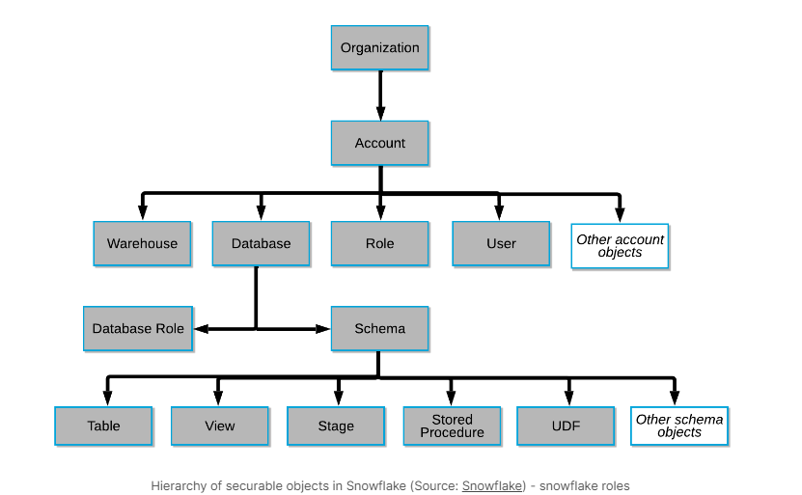

System defined Roles

ORGADMIN- ORG-
- This is the organization level role and it is used to create the accounts at the organization level.
- Orgadmin is used to access the all accounts and to see the account usage of each account under the organization.

ACCOUNTADMIN ACCOUNT-
- ACCOUNTADMIN is not a super user role. This role only allows viewing and managing objects in the account
- If the account is allotted then, first user of the account will have the account admin role.
- We will not assign the account admin roles to all users. We have to give the privileges only to the selected users.
- Account admin assigned users can create more than one users those who are assigned with useradmin role.
- Account admin must be assigned at least two users, since if any password reset kind of access related things can be done without any delay.
- If snowflake is taking these changes up to 2 business days, in that meantime we can utilize the other users to reset these things.

SECURITYADMIN
- Security administrator (user with the SECURITYADMIN role) or another role with the MANAGE GRANTS privilege on the account.
- Securityadmin is used to grant a role to another role
- And also security admin can grant a role to any other user.

USERADMIN
- Useradmin role is used to create a new user in the snowflake account and also it is used to manager the users like create user, modify users and also the dropping of existing users.

SYSADMIN-
- Sysadmin role is managed by accountadmin role
- And that is used to access the secure objects like tables, procedures and UDF kind of objects

PUBLIC-
- All Snowflake users are automatically assigned the predefined PUBLIC role,
- Public role enables login to Snowflake and basic object access.

Role & Role Hierarchy
# | Warehouse | Database | Schema | Tables
Dev Team | Cannot Create | Cannot Create | Can Create | Can Create
Dev Team | Cannot Alter | Cannot Alter | Can Alter | Can Alter
Dev Team | Cannot Drop | Cannot Drop | Can Drop | Can Drop
Dev Team | Can Use | Can Use | Can Use | Can Use

Security- sec-
In snowflake we are having several level of security to access the data and share the data
  - We are having the row level and column level securities in the object level
  - In column level security, we can apply the dynamic data masking functionality on the views or tables to mask the data as per the roles.
  - In row level security we can create a Row access policy and we can add into the table. It will act like a where clause and it will filter the data to the user.
  - Step to create a column level, we have to create a masking policy and then we can use the alter table with SET option to set the masking policy respective to the column.
  - To create row level security we have to create a mapping table and row access policy and we can use the alter table add to add the row access policy on the table level.
  - Row access policy limitations
- Row access policy not supports the stream objects
- We cannot use the external tables as a mapping table in a row access policy.
- We cannot create a row access policy for the future data.

Dynamic data masking DDM-
- Dynamic data masking is used to encrypt the data from the table or view or from the materialized view in the accessing role basis.
- We can create the masking policies and set to the columns in the respective columns using the ALTER TABLE SET command we can enable the encryption of the sensitive data, while accessing from snow flake data objects.
- Column Level securities
- Masking Policies
- Dynamic data masking
- Creating masking policies
- Applying masking policies
- Altering & Dropping policies

Column Level securities
Snowflake is having the column level securities to access the column from the table or view by applying masking policy
2 types
- Dynamic data masking
- External tokenization

Dynamic data masking
- We can create masking policies and applying policies on the required columns of the table or view,
- It will mask the actual data of the view or table at runtime.
- Say for example we can apply the masking policy with respective to the roles and in the run time we can change the role by using of USE command and we can access the masked or un masked data in the session.
- The data wil be there in the table but it wil not be visible to the roles ot user when it is masked

External tokenization
- Tokenization is used to hide the sensitive data in the columns like SSN number.
- Tokenization is will convert the data of the columns as cypher text.
- This will be used to apply the external functions to mask the data in the columns.

Masking- Policies policy- mask-
- Masking Policies are schema level objects. Masking policies includes the conditions , functions to change the data
- One masking policy can be applied on the multiple columns at the same time.
- We cannot add more than one masking policy to a column, if we try to add the more than masking policy to a column then, it will returns an error as “The column already attached with another masking policy”
- In that case we have to unset the existing masking policy which is applied on the columns and we can attach the new masking policy to the column.
- While accessing the columns, masking policies are applied in the columns and it will give the masked data.
- Masking policies can be applied on the columns which are having the sensitive data, personal information columns.
Commands
- Drop database mydb;
- Drop schema myschema;
- Create database mydb;
- Create schema myschema;
- Create warehouse mywarehouse1;
- Create role myrole1;
- Create or replace table mytab as select * from public_db.public.customer;
Create or replace masking policy mypolicy
As (Val string) returns string ->
Case when current_role () in ('myrole1') then Val
Else '##-###-###-'||substring (Val,12,4)
End;

Alter table mytab modify column c_phone set masking policy mypolicy;

- Grant usage on database mydb to role myrole1;
- Grant usage on schema mydb.myschema to role myrole1;
- Grant select on table mydb.myschema.mytab to role myrole1;
- Grant usage on warehouse mywarehouse1 to role myrole1;
- Grant role myrole1 to user gobikkannan8;
- Use role myrole1;
- Select * from mytab ;

Semi structured- semi-
- I have used Json, XML and parquet files in my project.\
- Once the file format and external stage is created
- We will create the stage table and target table
- In stage table, we will create the variant datatype and then we will use flatten to handle the nested data and load to the target table
- We will use the lateral function and I will select the array data using the index position and then I will load the data to the target table
- Semi structure data must be parsed using any of the functions to load them into a DB tables.
- In snowflake we are using the PARSE_JSON and also the flatten to parse the Json files.

Parquet- par-

JSON-
JavaScript object notations

Flatten lateral- flatten- flat-
- FLATTEN is a table function that takes a VARIANT, OBJECT, or ARRAY column and produces a lateral view (i.e. an inline view that contains correlation referring to other tables that precede it in the FROM clause).
- FLATTEN can be used to convert semi structured data to a relational representation.

Syntax
FLATTEN( INPUT => <expr> [ , PATH => <constant_expr> ]
[ , OUTER => TRUE | FALSE ]
[ , RECURSIVE => TRUE | FALSE ]
[ , MODE => 'OBJECT' | 'ARRAY' | 'BOTH' ] )

Structured data sd-
- It is a pre-defined structure like EXCEL, CSV kind of files and the data will be in the rows and columns.
- Customer records in a database with fields like name, address, phone number, etc.
- Structured data can be analysed by the sql or any other relation db tools and we can store them into a db tables easily.

Semi structured data
- It is not a pre-defined format and it will have the array of data inside,
- Say for example, XML, JSON are the semi structured one.
- If a data is having multiple sections for title, author, content, comments, etc., then that will be the semi structure data.

Unstructured data ud-
- Un structure data are not in the pre-defined format like text documents, images, audio files, and video recordings.

Variant-
- Variant datatype will store the Json file data , xml file data into a single column
- We can parse the Json data from the variant column using parse_json function
- We can store the maximum size of 16MB.

ARRAY CONSTRUCT
- This function builds an array from zero or more expressions. The data types of these expressions can be different. Even null values are included in the result.
- SELECT ARRAY_CONSTRUCT('hello', 3::DOUBLE, NULL, 4) AS my_array;

OBJECT CONSTRUCT
- This function constructs an object from zero or more key-value pairs. Keys must be strings, and values can be of any data type. The order of key-value pairs isn't preserved in the final object.
- SELECT OBJECT_CONSTRUCT('name' => 'Alice', 'age' => 30) AS my_object;

Data sharing- share- ds-
- Data can be shared securely using the data sharing option in snowflake.
- We can share data between snowflake users and to non-snowflake users as well.
- If we need to share data to the non-snowflake users, we have to create a reader account and share the data
- Here provider is like “Who is sharing the data by creating share object”.
- Consumer is like “Who is consuming or using the shared data”.
- Shared data can be consumed by consumers own compute resources.

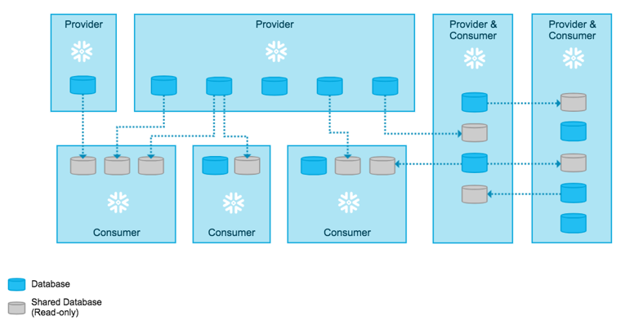
- We can share named database objects that contains all of the information required to share a database like the object grants and consumer account details.
- All objects like Tables, External tables, Secure Views, Secure materialized Views, Secure UDFs can be shared with other account users.
We wil be able to see the UI itself, to whom and al we have shared the data so far

Reader- Account
- If we want to share data with non-snowflake users, we can create reader accounts for them.
- Reader accounts (known as “read-only accounts”) provide a quick, easy, and cost-effective way to share data without requiring the consumer to become a Snowflake customer.
- Each reader account belongs to the provider account that created it.
- Readers can't perform any DML operations, they will have only select access.
- Billing will be calculated in Provider's account itself.

Limitations- in Reader account- in snowflake reader-
In the reader account, the users can only select (or read) the data that has been shared with them. They will not be able to run any DML statements (load, insert, and update) in the reader account.

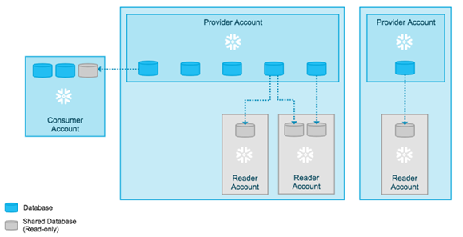

Cursors in Snowflake Stored Procedures cursor- cur-
- Cursor is a sql private work area, it is the named object and it is used to select data from the table and also, we can use the cursor to loop the data from the result.
- We have two types
- Implicit cursor
- explicit cursor

- Declaring a cursor either in DECLARE or BEGIN…END section of the stored procedure.
- Opening a cursor using OPEN command.
- Fetching rows from cursors using FETCH command.
- Closing a cursor using CLOSE command.

Procedures proc-
- Stored procedures are the object and we can use the stored procedure to perform the programing logics and that program can be stored inside the DB.
- Whenever we need to perform the programming action then, we can call the procedures using the call command.
- We can create the snowflake procedures using languages like SQL, JavaScript, Python, Java and Scala. I have used the SQL.

When to create procedure?
- Say for example, in our project, we are receiving data from the various sources like trade data and payment data from the AWS s3, and we are receiving settlement data from another application from the another s3 bucket.
- In that case I have to validate the functional data dependency of those data like all the payment are associate with the trade or not and then I have to check the all settlements are associate with the any of the payment or not. In that case I have created the procedure in snowflake to validate data in the stage tables.

Proc debug debug-
- whenever a procedure is taking more time to execute, i will call another procedure that is error_log_prc or time_log_prc inside the existing procedure.
- The procedure which is being called inside the existing procedure will be having the insert statement to log the time into the time_log_table or error_log_table.
- We will call that time_log_prc inside the existing procedure between every blocks and we will call it. Once called, the time will be logged in the time_liog_table between every blocks. Based on the time, we will check which part of the procedure is taking time and we will rectify it.

Variables in Snowflake Stored Procedure var-
- We can use different data types to mention the datatype of the variable.
- Type of variable can be
- SQL data type
- CURSOR
- RESULTSET
- EXCEPTION
- We can use the DEFAULT command to specify an initial value for the variable.
- A Variable in Snowflake can be declared either in DECLARE section or BEGIN…END section of the stored procedure body or both.

Using a bind Variable in a SQL Statement bind-
- The variables declared in the stored procedure can be used in the SQL statements using colon as prefix to the variable name.
- Example:
- DELETE FROM IDENTIFIER(:in_tablename) WHERE ID = : in_employeeid;
- If you are building a SQL statement as a string to execute, the variable does not need the colon prefix.
- Example:
- LET sql_stmt := 'DELETE FROM EMPLOYEES WHERE ID = ' || in_employeeid;

EXECUTE IMMEDIATE in Snowflake ei- exec- imm-
- EXECUTE IMMEDIATE command is used to execute a sql string inside the program block. (character sets enclosed by single quotes or double dollar signs).
- EXECUTE IMMEDIATE returns the result of the executed SQL statement.
- Single sql statement, procedure and also anonymous block can be executed by using of the execute immediate command.
- For example.
EXECUTE IMMEDIATE '<sql_query>';
EXECUTE IMMEDIATE $$ <sql_query> $$;

EXECUTE IMMEDIATE with USING clause in Snowflake
- USING clause is used to pass the value to the bind variable which inside the execute immediate section
- USING clause is pass the values in the position basis.

EXECUTE IMMEDIATE with INTO clause in Snowflake
- INTO clause is used to catch the output values from the execute immediate command.
- Number of columns selected in the select statement inside the execute immediate must be matched with the number of variables used in the INTO clause

- SELECT id, firstname INTO :id_variable, :name_variable FROM employees WHERE id = 101;

FOR Loop in Snowflake Stored Procedures for-
- A FOR loop enables a particular set of steps to be executed for a specified number of times until a condition is satisfied.
- The following is the syntax of FOR Loop in Snowflake Stored Procedures.
FOR <counter_variable> IN [ REVERSE ]
<start> TO <end> { DO | LOOP }
<statement>;
END { FOR | LOOP } [ <label> ] ;

Exception handling in procedures ex-

Pre-defined exception
- Statement_error – will raise when the table name or the column name is wrong
- Expression_error – data type and value related errors will raise the exception
- Other handler also can be used to handle

User-Defined Exception
- Raise keyword can be used to raise the user defined exception.
- It has 3 parts like declaration of exception and then raise the exception using any of the condition and then we have to handle it the exception handling section.

Doubt
- A <counter_variable> loops from the values defined for <start> till the value defined for <end> in the syntax.
- Note that if a variable with the same name as <counter_variable> is declared outside the loop, the outer variable and the loop variable are independent.
- Use REVERSE keyword to loop the values starting from <end> till <start>.
- If there are multiple loops defined in the procedure, use the <label> to identify loops individually. This also helps to jump loops using BREAK and CONTINUE statements.

REPEAT Loop in Stored Procedures repeat-
REPEAT
<statement>;
UNTIL ( <condition> )
END REPEAT [ <label> ] ;
- REPEAT is used to perform the repeated execution of the statements UNTIL the condition met.
- If we are using the REPEAT then UNTIL is mandatory for the loop exit.

BREAK command break-
- Break can be used inside the loop with any of the condition.
- Break is used to come out from the loop
- Break stops the current execution of the loop and also it will exit the program control to the out of the loop.

User-Defined Function func-
- A snowflake user defined function is an object, and that is used to perform a specific task.
- UDF can be called through the sql statements and it will return one row at a single call.
- We can create a single UDF and we can call many places with the different set of input parameters.
- We can differentiate UDF as 2 types.
- Scalar Function (UDF) – returns a single value.
- UDTF is a table function, that will return multiple rows in the single call

UDF syntax

A UDF can be called using a SELECT statement as shown below. If a UDF has arguments, you can specify those arguments by name or by position.
Select udf_name(udf_arguments);

A UDTF can be called in a way any table function would be called. A UDTF is called in a FROM clause of a query using TABLE keyword followed by UDTF name and its arguments wrapped inside a parenthesis as
Select … table (udtf_name(udtf_arguments));

In which scenarios you have written stored procedures and UDFs(User Defined Functions)? P vs f- pvf-
We can write stored procedures
- When there is a need to execute multiple SQL statements in some order.
- When there is a need to apply same logic multiple times or at multiple places with different parameters.
- To automate certain things.
- Say for example, In our project, we are receiving data from the various sources like trade data and payment data from the AWS s3, and we are receiving settlement data from another application from the another s3 bucket.
- In that case, I have to validate the functional data dependency of those data like all the payment are associate with the trade or not and then I have to check the all settlements are associate with the any of the payment or not. In that case, I have created the procedure in snowflake to validate data in the stage tables.
We can write UDFs
- TWhen certain functionality is not available through built-in or system defined functions, and we use that functionality multiple times.
- Ex: we can write a function to calculate Tax_Amount for all employees.

EXECUTE AS CALLER eac- call- caller-
- When a stored procedure or function is defined with "EXECUTE AS CALLER," it means that the procedure or function executes with the privileges of the user who calls it.
- The permissions and access are based on the privileges of the user invoking the procedure or function.
- This is useful in scenarios where the procedure or function needs to operate with the permissions of the caller rather than the owner.

EXECUTE AS OWNER eao- owner-
- When a stored procedure or function is defined with "EXECUTE AS OWNER," it means that the procedure or function executes with the privileges of the user who created it or the role that owns it.
- The permissions and access are based on the privileges of the user who defined the procedure or function.
- This is useful when you want the procedure or function to always execute with the same set of permissions, regardless of the caller.
In summary, "EXECUTE AS CALLER" adapts the execution context based on the user invoking the procedure or function, while "EXECUTE AS OWNER" uses the permissions of the user who defined the procedure or function. The choice between them depends on the specific requirements and security considerations of your use case.

External Functions ext-
- An external function calls code that is executed outside Snowflake and it relays on remote service.
- And that external functions can be used in the sql just like other single row functions in snowflake.
- External functions act as a bridge between Snowflake and external services, enabling us to harness functionalities like:

- Integrate with various third-party services such as geocoders, machine learning models, payment gateways, and more using API integration.
- We can Run custom Python, Java, or other languages written outside Snowflake for specialized tasks
- We can Expand Snowflake's functionality beyond built-in features by incorporating custom logic.

Complex user story complex- com-
- I have created the complex sql query to validate the trade payment logics
- For this purpose, I have created one single sql to validate multiple transformation tables and multiple scenarios
- In my trade transaction some trade may associate with payments and some of them yet to complete the payments, so those trades will not associate with the payment table
- Similar way, for some of the payments may complete the settlements and some of them yet to complete the settlements,
- For this purpose I have joined all the tables like trademaster , paymentmaster , payment_detail and settlement_details with left outer join to get the all details from master ansd the matched data from the payment and settlement and loaded al the data to the temporary table in the same procedure . so that all the sql queries have been merged and done the validation in one single shot by validating the data in the temporary table!
- This kind of standardization work I havave done !
- And also, when ever the repeated thiongs are coming in the pject hten , I will thjink about the automization of the things for the repeated tasks
- Like repeated execution of sql we can create that as material view and then we can share it to the dashboard team !
- And also we can creat the alerts for the reaching thresholding of the usage
- And also we can reduce the query exceeding time when the sql is taking more time then that sql session has to be timed out!

Estimation of the Task est-
- I will consider two hours for analysing the requirement.
- And, I will consider half day for preparing Detail design document and impact analysis document.
- After getting approval from my lead, I will start the development.
- In the high level, based on the requirement after analysing, i will consider four days to five days for development
- and then will consider half day for unit testing.
- Once all my unit test cases pass, I will sign off from dev side.

Till start to end till-
- We will get the requirement from Business team as RSD(Requirement Specification Document) and It will be created as a ticket in JIRA by my team manager
- Jira tickets contains information about
Detailed information about the CR point
- RSD document - Requirement specification document / FSD (Functional Specification Document) / FDD (Functional Design Document)
- Prototype / Screenshot - is for understanding the requirement with more clear
- In Comments section, there will be comments about any discussions happens about the requirement
- Jira ticket assigned date / assigned by / assigned to / Expected completion date /working hours
- Jira will be assigned to my name by my team manager
- I will open the JIRA and lookout the description and analyse the what are the new objects has to be created and objects has to be changed
- I will check out existing procedure / object's scripts from Git (development Branch)
- I will do the modification and I will checkin to the new branch which I have created in the Git with name of JIRA ticket
- after completion of my development, I wil ldo the unit test case and raise the pull request for peer - peer validation
- "I will raise the pull request to my teammate for peer-peer validation of my code
- ( pull request created from stash( application which connected with Git)"
- peer - peer validation completed then he will approve the code and merge the code with development branch
- JIRA status will be changed by approver in dev-competed

Documents docs- doc-
- Requirement Specification Document
- Technical Design Document
- Impact analysis document.

Technical Design Document
It will contain the introduction and also the
- Introduction
- System Architecture
- Data Modeling details
- ETL/ELT Processes whatever we are following in the process
- Deployment Strategy what we need to follow

Impact analysis document
- For CR points and Customizations requests we have to create impact analysis document
- We have to take the dependency object list according to object which I'm going to change
- Find the dependency object list by using of get_object_references
- SELECT * FROM TABLE(GET_OBJECT_REFERENCES('MY_DATABASE.MY_SCHEMA.MY_VIEW'));
- I will open each object source code and identify the impact of my change
- I have to provide dependency object list / impacted object list in the document with clearly mentioned the required changes as well
- I will get approval from my tech lead for the impact objects
- While doing changes, I have to provide the change for impacted objects as well.

It contains,
- CR point ID
- Created By
- created On
- Cr point description
- Dependency object List
- Impacted Object List with change of each object

Mapping- mapp-document- doc-
- Mapping sheet can be created based on the RSD and requirements discussed on the grooming call.
- Mapping sheet is used to identify the data logic or business rules, data flow.
- Mapping sheet can be referred for the transformation between source and target.
- Mapping document contains Source tables, staging tables, target tables and column name, data type and data length and constraints details and transformation logics.
- So that other than dev team can understand the data flow and business logic for testing purpose or validations as well business needs.
- We will share the mapping document to QA before data reaches to QA environment.

Day to Day activities day-
- Analyzing Requirement Specification document and prepare detail design and impact analysis document.
- Involved in getting approval of the document from the architect.
- Based on the RSD, created new objects and modified the existing objects like procedures and functions using language sql and snow pipe, task etc.
- After development, done unit testing and ensured the changes working in the application.
- Involved in code review with peers and also finally with architect. After the approval, will move the code to SIT for testing.
- If any bugs assigned, verified and closed the bug.
- Also, checked why it has been assigned and ensured it doesn't raise again.
- I attend Scrum meeting and update status on a daily basis.
- I'm the individual contributor in my team.
- These are my responsibilities and day to day activities in my project

AWS-
- We are using the AWS as the cloud data source
- We are using the aws services like s3 to access the data files, redshift for the database access,
- And we are using the IAM for the assigning roles.

IAM-
- IAM is the Identity access manager
- IAM is used to give the permissions to the s3 bucket based on the roles.
- We will create the roles and we can assign the roles to access the s3 bucket
- We are having dedicated AWS team to provide this kind of access to snowflake team.

Validations in aws redshift- red-
- I involved in cloud data migration validations
- In our project our target oracle database is created on the aws (amazon web services) cloud
- We used RDS services to connect the oracle database which is in the AWS into our local environment, database connection service
- By using of the same rds service we will connect the aws oracle into our sql developer and we will validate the data by using sql queries.
- We can use the same sql syntax in the aws redshift , so I have involved in the data validation in the migration of data.
- Redshift is used in the one of the layer in the aws we are using the ETL layer in the REsdhift
- That is also similar with the sql only
- But this was used in my previous project not in the recent project.

S3
- S3 is specific to AWS which does Simple Storage Service
- Its designed to store and retrieve large amount of data, such as files, documents , images , videos and others
- Accessibility for S3 is universal
- We can transform data from S3 directly by upload and download, or by S3 transfer acceleration or AWS datasync for large-scale data transfer.
- In our project we access the files from s3 and load the data into the snowflake tables
- One of the source we have s3 file so we will get the file from the s3 and then load it to the snowflake database
- We can use the python frame work

S3-
- S3 is a cloud service from the aws cloud
- This is simple storage service and it is used to store the files like flat files, json files and images in the aws cloud.
- And also s3 allowed to create the directories and we can keep our files in the respective directory with the respective permission.

SQS-
- Simple queuing service Notifications can be sent to a SQS queue for a server to read.
- It is the queuing service, and also it will deliver the message after sometime, when the target receiver not in available. So, this will notify the pipe once file got uploaded in s3.

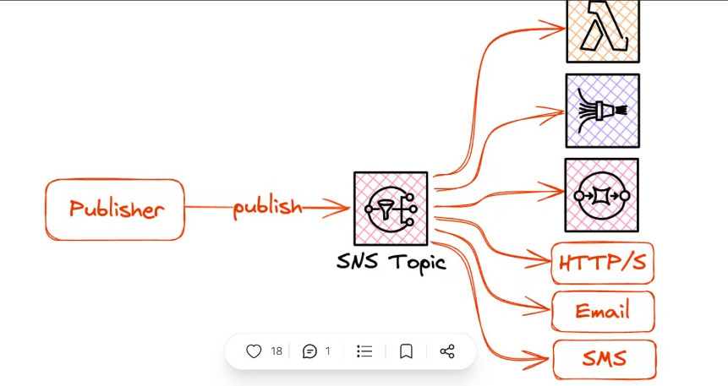

SNS-
- Simple notification service Fan-out will deliver the notification immediately.
- And messages to systems for parallel processing or directly to people
- SNS is super performant. And SNS will deliver the messages within milliseconds.
- A common pattern is a fan-out pattern that allows one to fan out one event to various subscribers within AWS.

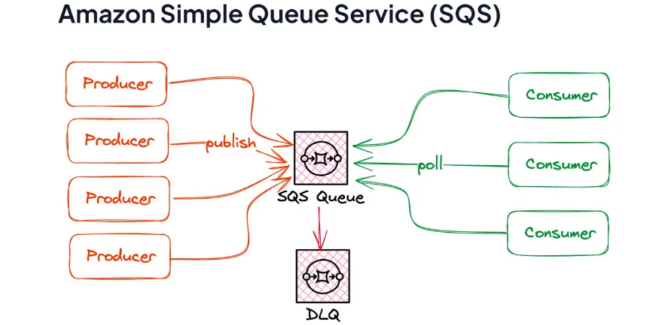

Project-
- Our Project is Banking application, In the banking we are part of investment banking
- Our application handles the trades which happening between two counter parties or else counter party and with the legal entities.
- we are tracking the payment information and settlement information and accounting setup for each deal
- We are having the trade, payment and settlement data sources as files from s3 bucket at AWS
- We are using file as source and I have created the stage object at snowflake database and then we are using the snow pipe to enable the auto ingest to the stage table in snowflake, THAT ACCEPTS THE DATA FROM THE SQS NOTFICAITON AND IT WILL LOAD THE DATA
- Once the data is reached to the stages then we are applying the transformation logic on the data and we are loading the data to the target tables
- We are using the procedures to implement the transformation logics and also, I have used the stream object to capture the changes on the tables for an audit purpose.
- I have used the parse_json function to parse the data from the json files.
- So that I have created, pipe objects, stream objects and also the masking policies to mask the data at the runtime to enable the dynamic data masking.
- That is short about my project.

Our project allows us to generate reports like,
- Branch wise active deals details . Mature deal details / error deal details
- the same reports can be generated in branch level , counter party level and from date to date range level as well
- we have deal summary screen to display the trade details in the screen level
- In same screen, if we select any of one trade Id , We can see the payment information of the deal
- and settlement information of the deal and accounting information of the deal in various new windows
We have transformations like, I have created the sql to validate the data like, customer wise number of trades, number of trades in the branch wise kind of aggregate transformations and I have used the joins to select data from the multiple tables
We used to validate the data in the month wise trade count, year wise sum of trade amount and these details I have calculated in the branch level, year level and month level

Functionality of my project func-
- customer will place trade
- we have to capture trade details and maturity details
- and the respective account details we have to post our maturity amount
- payment life cycle (EMI) amounts hs to be posted to the accounts
- if Payments are completed then, we will call that as Matured Deal

Trade life cycle lc-
trade creation - trade payment - Trade settlement - Trade maturity.

Project PA-
- We are having multiple sources as oracle and file system in the AWS s3 cloud.
- For oracle, we used IICS to load data from oracle to snowflake
- And for s3, We are using the external integration with the AWS s3 bucket to load the data to the external stage.
- We are using structured files like CSV,and semi structured files as Json ,parquet files to load the data to external stage.
- From the external stage we are parsing the data using the Parse_JSON and flatten kind of functions to load the data into the landing layer.
- We are applying business rules like, versioning of trade, summation of payments, count of trade in each branch and we loaded to the integartion zone.
- And the last target layer we are loading the transformed data.
- Our downstream is power bi team.
- From the target layer only, data will be selected by the BI applications.
- We will share as views or mviews.
- This is about my current project, and in the previous project, I have been into migration from oracle to Snowflake

Layers- Layer-
- We have three layers in our project that is Stage layer, Integration layer and consumption layer.
- In stage layer, we will have the raw data which we get from Oracle and s3.
- We create stream on the stage tables and from the stage layer, data will be loaded to the integration layer where we apply the business rule and create task and stream on that. We will apply the logic in the procedure and finally load the data to the consumption layer. And from the consumption layer, we will create views and m views to share the data to the power bi team.

Migration- mg- mig-
- I have been into ORACLE to snowflake migration
- We are using the informatica IICS tool to load the data from oracle to snowflake
- we are connecting oracle in the source using the DB connection manager in the IICS and we are using the snowflake as target and we are loading the data to target snowflake in transient tables
- We are using the validation procedures to validate the data from the stage tables like, functional data validation, master data validation, null data validation in the stage table data.
- If any disqualify data is there in the stage then we are putting them into an error log table.
- After calling of the validation procedure, if we are not having any INVALID data in the error log table then we are calling the data load procedure to load the qualified rows to the target table.

Common checks in the migration!
We also do common cheks like
- Number of tables to be migrated
- Number of rows in the each table
- Target table name and columns
- Number of columns in the target table matched with the source
- Data type of the column in the source and target
- Transformation logic, if anything used in the migration
- Constraint details
- Table loading order .
- Majorly in snowflake, we have been validating using the validation procedure

Common- errors facing while migration err- cm-
- I will check Source file permission errors
- Source access directory permission errors, Example s3 allowed locations may not have the proper read permissions
- Data type related errors, that already handled by snowflake that is datatupe mismatch
- File format name mismatch,
- Stage name and the copy options in tehcopy has to be taken part
- Snowflake is not having proper constraints to enforce the data, since we may face the duplicate data loaded in target .
- It was like copy options like in file size and also dataytype mismatch in the sense, we wil check it in the IICs tool vbecasu ewe used iics tool to migrate data from the otravel to sf
- Also, constarinst
- And also, we can check the null data loaded to the not null columns
- And we have to check the referential integrity issues!
- We wil check the relation shop and orphan data in the dimension and facttable

File Loading errors err-
- File name and file permission related errors
- File may have the header! While loading it may try to load the header data as well
- Delimiter may be inside the data as well, in that case it will throw the error, we have to use optionally enclosed by command to overcome this error.
- Wrong delimiter may be used while loading.
- Data type mismatch in the file data
- Fields mismatches in the file data.

Validate data loaded or not-

- We can compare the data loaded between the source and target using the log files which has been generated by the informatica IICS.
- If that is file to table load then we can check the data availability in the stage
- And also we can check after the copy command as number of rows processed
- And also Select $1,$2 from stage/filename to check the data availability in the stage.

GIT-
- We are using Gitlab and also GitHub Desktop in our project.
- We merge in our code in GitHub desktop.
- I will click on the current branch
- And, then i will click on "Fetch origin" and "Pull origin" buttons to take the latest changes from the remote repository.
- I will compare the code in the current branch with the code I merge using win merge tool.
- After comparison, if all fine, I will merge my changes by providing proper message and click on commit.
- That will commit my changes to the branch.
- Then, I will click ‘Push origin’ button as Pushing sends our committed changes to the remote repository on GitHub so my colleagues can see them.
- My proejct is pipeline project, so used Jenkins from moving dev to sit

How you use GitHub Desktop?
- we clone the remote repository from the GitLab using https and proceed further.

Why GitHub Desktop?
- We don’t have direct access to GitLab as organization’s many projects are maintained in it. That’s why we use GitHub Desktop and it is more user friendly.
- Some projects use GitBash or other command-line tools for merging because it provides a more direct and detailed control over Git commands, especially when dealing with complex scenarios or conflicts.

JENKINS- jen-
- Jenkins is a platform for creating a Continuous Integration/Continuous Delivery (CI/CD) environment.
- In my project, we run pipelines by building parameters with appropriate details.
- After pipeline execution completed, I will check the result by clicking on console output.
- If the pipeline fails, will check whether the parameters have been provided correctly.
- We have SSU(Self service Utilities) to be referred and this helps us to resolve our issues rather than connecting with DBA team like PROD and NON_PROD instances password issue.
- After merging code in GIT, we run SIT pipeline and will check whether the changes have been reflecting in the respective DB instance and the same applies to UAT pipeline.

SOAPUI api-
- SOAPUI is an automation tool.
- We involved in manual validation in SOAPUI.
- We created source and sink connectors using create connector option in the Json file format. We have standard Json file format and we fill details like Connector name, field names, table name, connection details like URL, password and mode (insert/update/upsert).
- We checked the status using Connector status whether it is running.
- If it is not running, will check the error and fix it.

Data Governance gov-
It is one of the main features in Snowflake that ensures the highest levels of governance for your account and users, as well as all the data you store and access in Snowflake.

Change-
- I didn't feel there was an opportunity to grow or advance further in my current role so i decided a change would be best for my carrier at this time.
- No specific reason for the change.
- And also for my Career growth and financial growth.
- And I feel like sitting in a same company for a long time, so I decided to move
- feel like am doing the same thing again and again in this role
- and there is no scope for cloud and other advance technologies
- I can learn the data structure, data frames, data validation techniques , data quality control
- But here projects are getting over.
- For carrier growth am looking for new opportunity.
- My current ctc is 0.0 and expected ctc is 0.0.
- Its been around _ _ Years I worked in this company. So I decided to move out of it and explore some new project and new environment where I can able to gain some new knowledge.
- I want me to put in a new challenges
- Not in the project project , its not possible in the same orgization
- Its in pipleine
- With my 2 months notice. i tried for a change without dropping my paper
- But no HR is ready to schedule me the interviews all are preferring only immediate joining within 15 days
- Since all HR are preferring immediate joining , I dropped the paper earlier and hunting for job in the last month of my notice period. Now interviews in pipeline I can get the offer
- Also for my carrier growth am looking for
- (like cloud technologies with azure or AWS or GCP and some new testing tools)
- There is no specifc reason for my relaving
- Since all hr is preparing immediraer joingin I put dow
- I have read the job description and as you require the candidate to do support . i believe i would be the perfect match for this position.
- Also I wanted to work in a project where cloud projects are involved
- And I started learning the AWS redshift for this change

QQ-
- May I know the project details like database, tools and methodology you use?
- And may I know what will be the next process in interview process?
- Could u provide ur suggestion on me of the interview to improve myself
- What is the expectation on me on project perspective if am the part of the team.
- May I know .What will be the next step in the interview process.
- Just wanted to know ,Whether it’s the same relational DB or it’s the heterogeneous database validation.so that I can brush up my skills on that part
- Do I need to prepare or brush up anything to contribute more for this role in project?
- If am successful in this round, and if ever thing goes good. What is the next steps of interview process.
- May I know what do you like most about working in this organization?
- What are the different opportunities available to grow in the company so that I can contribute better?
- What is the most important thing that somebody planning to join this role should know.
- I don’t have any other questions. Am good from my side.

Software project environment
- DEV- Development Environment
- SIT- System Integration Testing
- UAT- User Acceptance Testing
- PROD- Production Environment
For Front end and backend developers dev, test, uat and prod environment is common

Dev- Development Environment
- it is used for development of the code
- Developer will have full access for this environment
- Developers will do the development env
- Developer will test the functionality which you developed here (UNIT TESTING)
- If unit testing is OK then Code will be promoted to SIT environment
- Development will happen in Separate database (separate schema)

SIT- System Integration Testing (Our Environment)
- Professional testers will test the functionality whether it is working or not,
- They will understand the functionality and as per their plan they will execute some test cases
- If any failures occur then, code will be sent back to the development team.
- If everything is OK then, Code will be promoted to the UAT environment.
- SIT will happen in Separate database (separate schema as well)
- For SIT database we will not have any DML / DDL privileges / We can select the data from the database.
- We can’t modify anything in SIT

UAT– User acceptance Test Environment
- Environment is accessed by customers (End users)
- Customer will test the functionality with their inputs.
- In case of issues then, code will be sent back to SIT team
- If everything is Ok then, Code will be promoted to PRODUCTION
- It will be in Separate Data Base – Separate Schema
- We can’t access the data, some of them from our dev team can access the data
- But any case we can’t perform any DML / DDL in this environment.

PROD- Production Environment
- High secured environment
- We can’t perform any DDL / DML here
- We can select the data, in case of any production issues validations
- It will be in Separate DB – Separate Schema

ETL

ETL ARCHITECTURE
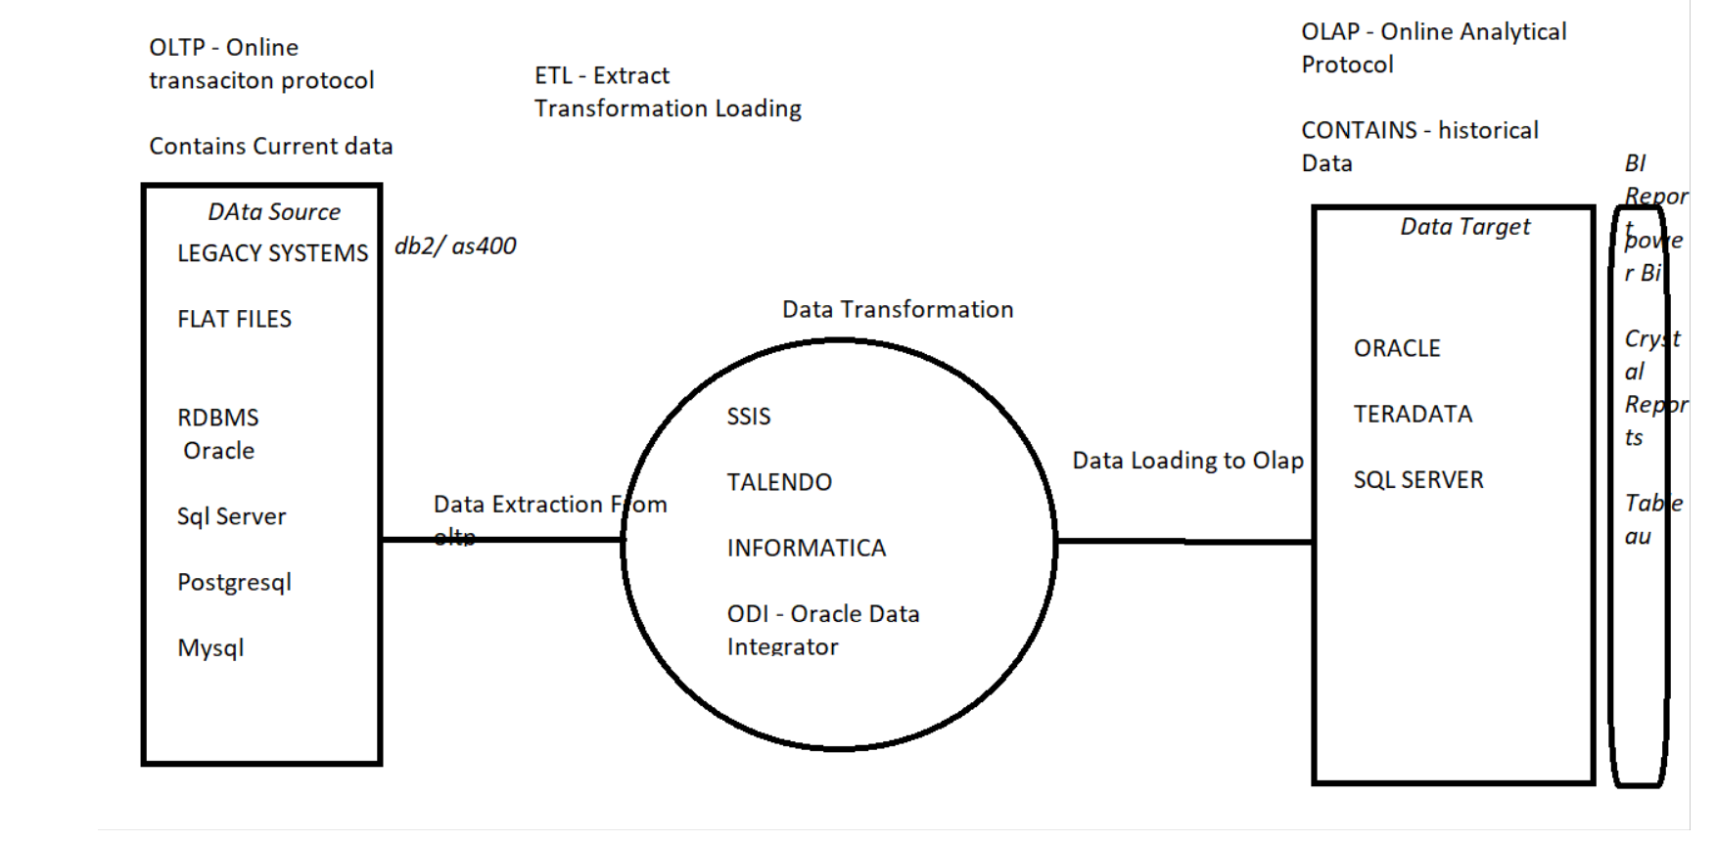

ETL Architecture-
- ETL is Extract Transformation and Load
- Extracting the data from OLTP environment and transforming the data into the ETL tools and loading the data into the OLAP environment
- OLTP can have multiple data sources called flat files and Data bases and also legacy systems databases.
- ETL will have Source area, staging area and Landing area
- Source will be OLTP Db or else files
- Stage will be any of Relational Data Base Management System (RDBMS) databases
- Target will be a database (RDBMS) .
- We used IICS etl tool for migration and maintaining the worklfows
- OLAP target will designed like fact table and dimension table types and created as snowflake or star schema design.

Why ETL- Testing is need-ed?

- Data warehouse will contain the historical data
- As a tester We have to validate the data which are migrated from the source to target
- Warehouse must have the proper valid data else Business Intelligence (BI) reports will give the irrelevant output
- we need to ensure the data in the data warehouse to make the decision-making system useful.

What is Normalization- nf-
- Normalization is a technique to accommodate huge data in the less storage.
- By using of normalization, we can avoid data redundancy (duplication), so we can accommodate data within the less storage.
- By using of primary key and foreign key constraints we can access the data between the relevant tables.
- We have 3 forms
- First normal form will have the multiple data into the single cell
- Second normal form will have the data duplication, data will be in the same table.
- Third normal form will have multiple tables, and it will connect with the primary and foreign key

Denormalization-
- will reduce the tables and number of joins.
- Data can be taken from the without using joins and we can access the data from the huge data without the joins
- And number of tables will be less in the denormalized environment
- Data warehouse will be partially demoralised.
- To maintain the historical data, we can use denormalization

OLAP- Vs OLTP-
OLTP– ONLINE TRANSACTION PROCESSSING
- OLTP is a data source it can be a flat file or database
- It contains normalized data and current year data
- It contains regular transaction data
OLAP- ONLINE ANALYTICAL PROCESSING
- OLAP will contain historical data and it must be a database
- It contains denormalized data and huge volume of data
- BI – reports will run on OLAP environment
- OLAP will be a data source of BI Reports.
- Snowflake comes under the OLAP!

DB- Vs data warehouse- DWH- DW- lake-
- Database contains the regular transaction data
- Database is the normalized environment
- Database will occupy less storage

- Data warehouse will contain the historical data.
- Warehouse will have the huge data and it will store the data in the database only.
- Warehouse is the de normalized and it will consume huge space

- A data lake is a centralized repository for storing and managing large volumes of raw and unstructured data, including structured data, semi-structured data, and even raw binary data.
- Data lakes can store a wide variety of data, including text, images, videos, log files, sensor data, social media feeds, and more.
- This data can be structured (e.g., CSV, JSON) or unstructured (e.g., text documents, images).

Data Mining-
- Data mining is the process of find the useful information for the business by analyse the large datasets from the data warehouse
- We will do data mining from data of data warehouse
- Data warehouse will have data from the source but data mining wil have the meaning full information that client needed.
- For example, we able to find the customer age, customer gender for the people who are all mostly buying the mentioned product.
- So I will create the sql to get the specific data from the large volume of data so that we can get the useful information from large set of data.

Data mining-
Data mining is the process of analysing data from different perspectives and summarizing it into useful information - information that can be used to generate BI reports that helps in increase revenue, decision making, cost cutting, etc.,
Data warehouse will have the historical data and this is the source for data mining
It allows users to analyse data from many different dimensions or angles, categorize it, and summarize the relationships identified. Technically, data mining is the process of finding correlations or patterns among dozens of fields in large relational databases

Data Profiling- Pro-
- It is used for Analysing and examining the data within the warehouse to gain insights like data quality, structure, relationships, and content.
- Data profiling helps identify data quality issues such as missing values, duplicates, inconsistent formats
- Data profiling examines the structure of tables, columns, relationships, and constraints in the data warehouse.

Data reconciliation- recon-
- I will be Comparing data from multiple sources or data sets to ensure consistency, accuracy, and alignment.
- This helps identify discrepancies, errors, and inconsistencies between different sets of data, such as source systems, transformation processes, and target tables within the data warehouse.
- In my project I used the sql techniques to validate the data between various source to the target database
- In this first we have to understand the what are the source we have along with the source to target data loading logic along with the layers between them.
- Then we have to extract the data from source and prepare the SQL as per the transformation logic and convert the data and compare the data against the already loaded data in the target.
- By this way we can able to Identify discrepancies, differences, and anomalies between the data sets.
- Discrepancies can include missing records, data value mismatches, duplication, and other inconsistencies.
- Then we have to find the Root Cause for the issues and work with the concern developer to resolve it

Data sampling- sam-
- Data sampling will be more useful while we are dealing with large set of data.
- Instead of analysing the entire data we will select the subset of data from the larger dataset
- Large data set validation will be more time consuming
- The common data sampling techniques are
- Simple Random Sampling
- Stratified Sampling - dividing the dataset into distinct subgroups and selecting samples from each subgroups
- Systematic Sampling - selecting every nth data point from the dataset
- Cluster Sampling - dividing the dataset into clusters or groups and then randomly selecting a few clusters
- Reservoir Sampling - It involves maintaining a fixed-size sample while processing each data point.
- Sequential Sampling - selecting data points one at a time and updating the sampling strategy based on the results of previously selected data points

ETL- Extract Transformation Load vs ELT- Extract Load transformation
- In ETL, Transformation will happen before data reaches in the target
- In ELT, Transformation will happen at the target
- Based in the data volume, we can use the ELT, if the data is huge and the ELT is the latest approach.

Why We are using ETL- tool- | Why ETL-?
- Transformations between the source and target:
we can perform multiple transformations between the source and target table columns by using of the ETL tools.
- Parallel Load: ETL tools supports parallel load, so loading will be faster.

Transformation types trans- tran-
Transformation is a process of converting data from one form to another, as per the BI needs.
we can convert the data by using of joins, aggregation or any analytical things from one form to another while loading of the data.
- Copy- column transformation – it will copy the data from the source to target without any transformation
- merge- transformation – it will merge two data sets into a single data set.
- Casting- transformation – it will convert the data type from one to another, (Eg: number to char)
- Filter- transformation – By using of some conditions data will filtered and loaded into the target.
- Aggregate- transformation- Aggregate operations will be performed in the source data and it will load to the target
- Union All- Transformation – It will merge multiple sources of data and load it into the single target.
- Lookup- transformation – Create the mapping between the lookup master and transaction table.
- Joiner- Transformations – Joins multiple tables and it will load it into a single target.

ETL Schema- Design
- STAR Schema
- SNOWFLAKE Schema
- Galaxy schema
- FACT tables
- Dimension Tables
- Slowly Changing Dimensions (SCD Types)

Fact-Tables table- tbl-:
- It contains foreign keys and has measurement of the business transactions
- One Fact table may associate with multiple dimension tables
- We have fact table like ft_trade, ft_payment, ft_settlement, ft_receipts

Dimension- Tables table- tbl-:
- Dimension Table contains detailed information of the fact and it has primary keys
- Dimension table will not contain duplicates
- Dimension tables are the parent table of fact tables
- Fact tables will join with Dimension tables.
- Dimension tables will have master data, so while loading the data, we have to load the dimension table first, and fact table next.
- While doing the data clean-up, we have to remove the fact table data first and then we have to remove the dimension table data, since fact and dimension tables are having the integrity constraint relationship between them.
- Dimension tables are having the master data, so that we have to load the dimension first
and we will have the types like Slowly change dimensions and late arriving dimensions
Dim tables like, Dm_customer, dm_branch, dm_currency, dm_legal_party etc

Types of Dimension tables: dimt-
- Slowly Changing Dimensions - Attribute values changes slowly over time. Based on the frequency of data change and history preservation
- Conformed Dimension - A conformed dimension is the dimension that is shared across multiple data mart or subject area
- example
- We have paymentid in the fact like that is shared across multiple dimenstion like payment_maseter , recipt_master
- Junk Dimension - A junk dimension is a grouping of typically low cardinality attributes, so you can remove them from main dimension. That is high duplicates
- Degenerate Dimension - A degenerated dimension is a dimension that is derived from fact table and does not have its own dimension table.
- For example, receipt number does not have dimension table associated with it. Such details are just for information purpose.
- Role play Dimension - Dimensions which are often used for multiple purposes within the same database are called role-playing dimensions.
- For example, we can use a date dimension for “date of sale”, as well as “date of delivery”, or “date of hire”.
- Late arriving dimension - A late-arriving dimension has a natural key which exists in the new fact data, but which does not yet exist in the dimension
- We will have dummy and default value in the dimension table and when the dimenation comes then we will map it with the respective records.
- Where we will get the payment id fro the future payment where we will keep it as the late arriveing diomention

Type- of fact- tables:
- Transaction Fact Table
- Snapshot Fact Table
- Fact less- fact table
- Aggregate Fact tables
- Additive fact table
- Semi additive fact table
- Non additive fact table
Transaction Fact Table
It will contain the transaction data and business measures.
We can see the measure in the column
Snapshot Fact Table
It contains the state of the data in the particular time period. Snapshot fact table contains the row_effective_date, row_end_date, row_active_indicator to identify the time of the data.

Fact less- fact table
FACTLESS fact tables will not have any measures,
it is used to show the relationship between the multiple dimensions.
Fact less fact table will act like the set-up table and it has the many to many
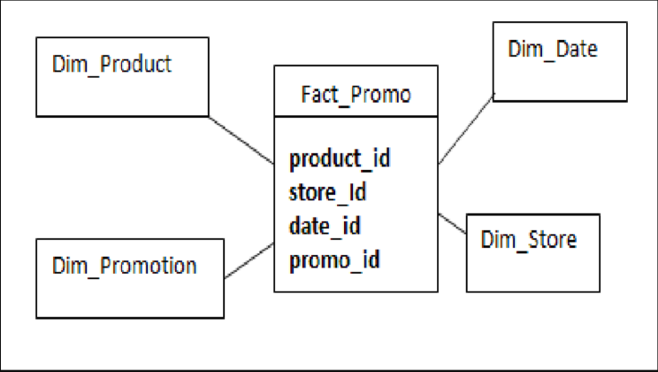
relationship between the dimension tables.
It acts a bridge beteen two or mor etables

Aggregate Fact tables
If we use any aggregate functions in the existing fact table and created an aggregated output in the other fact table then that is called the aggregate fact table. Number of records will get reduced in the aggregate fact table.

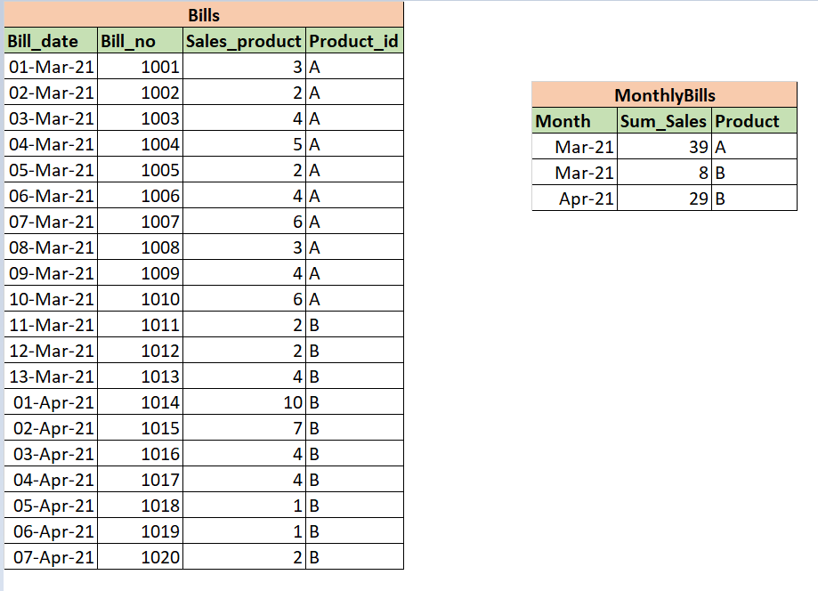
Daily based bill details aggregated and inserted into Monthly Bills Table

Additive- Fact
Additive facts are those facts which give the correct result by an addition operation.
For Example, if the fact contains number of trades, trade amount, these can be added and get the desired result.

Semi Additive- Fact
It is oen fo the types of fact!
Semi additive facts are facts that can be summed up for some of the dimensions in the fact table
For example, we can take total number of trades till date from the warehouse, and we cannot take the sum of the fact in the long period.

Non- additive Fact
Non-additive facts can also be added, but the addition gives incorrect results.
Some examples of non-additive facts are average, discount, ratios, we cannot get the proper measures, if we add them.

Grain- of a fact table
Grain of fact table means, like level of information that is provided in the fact.
Say for example, if the fact is giving the information in the Quarter basis and monthly basis then that is the grain of fact, and it is not having the information as date wise.

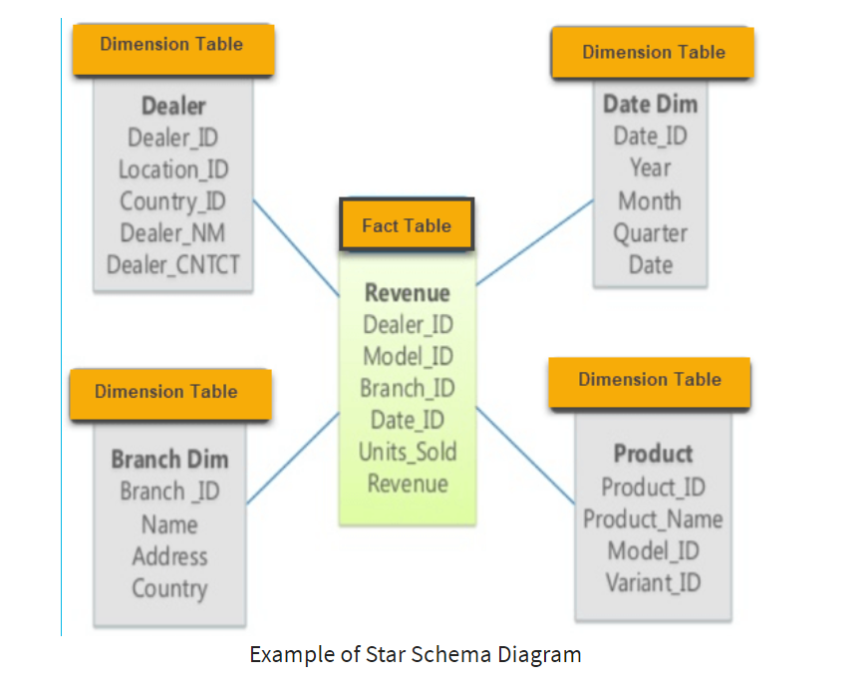

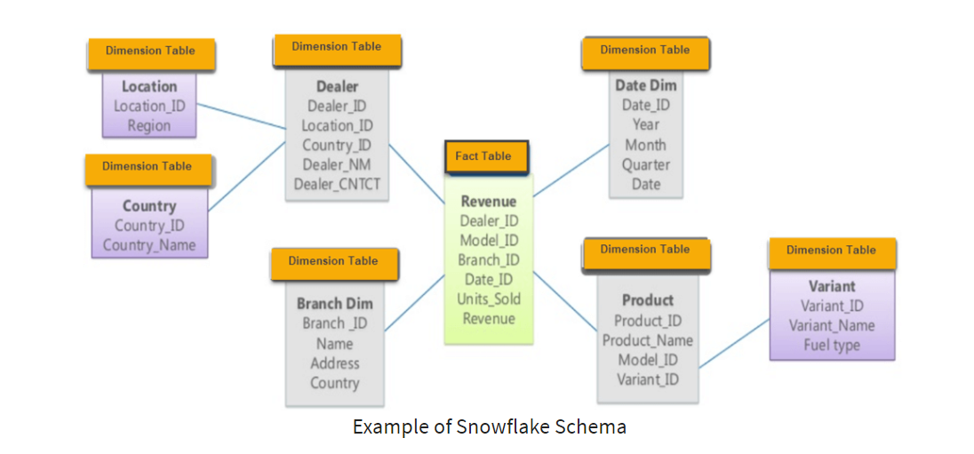

Star- Snowflake-
Theer are schemas

- In Star Schema One Fact table may associated with Multiple Dimension tables
- It is the de-normalized environment
- Star schema will give better performance in the reporting basis
- In Snowflake Schema, Dimension will be act like a fact of some other dimension table
- Dimension table will be separated as sub dimensions
- Snow flake schema will be in normalized environment
- Snowflake can accept huge data in the less storage so we are using the snowflake
- Data duplication will not be there in the snowflake schema, since it is normalized environment.

Why Star-
In star shcema,
- Reports can be generated without complex joins
- we no need to perform joins on multiple tables, since Star is a denormalized environment

Why Snowflake-
- In my project Trades table contain huge data, so snowflake is the option to store the huge data in the less storage, and that is the reason we are using the snowflake .
- So to handle al the hostical data from my trade_dtls table, we used to load al data to the fact tables based onX

Galaxy- schema gal-
If we are sharing the dimension table with the more than one fact table then, we can call that as galaxy schema.
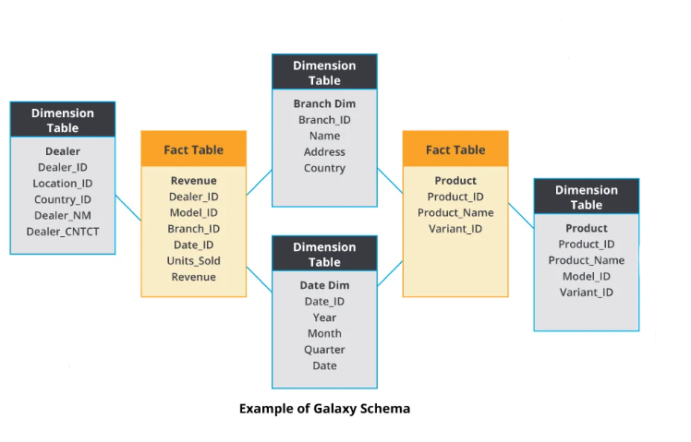

SCD- types Slowly changing Dimensions
This is the technique to store the history data in the dimension table
We have 6 types of SCD, and they are type 0,1,2,3,4 and 6.
- Type 0 – Fixed Dimension
  - In Type 0, changes will not happen and dimension never changes.
- Type 1 – No History
  - In type 1 Records will get updated in the current records. History details will not be maintained in the type1.
  - In other words, History details will not be stored.
Type 1 and Type 0 will not have the historical data, it holds only the current data.
- Type 2 – Row Versioning
- In our project we follow SCD type 2
- Track changes as version of records with current flag and active date columns.
- We have version columns to split the current data and historical data.
- If the version is 0 then, that denotes history record
- If the version is 1 then, that denotes the current record.
- We have start date & End date columns to find the duration of the data.
- To store the history properly with date interval, we will follow scd2
- Type 3 – Previous Value column
  - We have the new column to capture the previous version of the column value. It will hold the previous data of the same column.
Type 2 is the row level history management and, entire history will be available at type2
And type3 is the column level history management
And we will have just the previous version of the data in the respective column
- Type 4 – History Table
  - Type 4 will show current value in dimension table but it will track all changes in separate table
  - It will be similar with the scd2 only.
Type2 & Type4 tables will have the surrogate keys in the rows, since these types will have multiple versions of data.
- Type 6 – Hybrid SCD
  - Type 6, will use the multiple techniques like, type2, type3 in the same table itself.
  - We can use all techniques in the same table together.
https://adatis.co.uk/introduction-to-slowly-changing-dimensions-scd-types/

Why SCD-2 we are using scd2
It is row versioning!
- SCD 2 is used to store both current row and historical data in the same table
- By using of the version column, we able to identify the current row and historical rows
- And also start date and end date columns are used to find the duration of the data
- If the version is 0 then we will say that as historical row and if that is 1 then, it denotes the current row.
- If new record is loaded to the scd2 table then, previous version of the same data version and end date column will have updated and it will be updated with version as 0.
- We are doing insert, update and soft delete operation in the scd2 table.
- In our project,
- we are using the stream and task for it and we wil just insert from the procedure!
- For the banking domain we have to store the entire history of the data to track the old changes and entire history of the data. If we have the changes in the trade amount or customer details, then those changes will come in the updated record of the scd2 table and if the new trade arrives then, that is the insert data.
- If we need to remove the trade then, we will do the soft delete .
- Now in snowflake, we are using streams and tasks to maintain the historical data
- This is the reason we are using the scd2 in our project
- Finding the history details from the scd2 table is easy, comparatively.

Full- Load- Vs Incremental- Load
To migrate entire data in the single shot is called full load
Migrate the data in the incremental basis, that is called incremental load
First load of the incremental load is called the initial load
In the incremental load, Load will happen daily basis, or weakly basis or else monthly basis

Surrogate- Key
- Is a technical key and it contains Running Serial numbers.
- It will not have any Duplicates and Null Values
- It is used to avoid multiple join conditions while writing join -based SQL.
- Surrogate key always be in Number data type, Since Number will be joined faster than varchar2
- Surrogate key column values will not have any business meaning, and it will not come in any reports

Why Surrogate Key
- If we have multiple columns as composite primary key then, it is difficult to join, in that case we can use the surrogate key to join the table easier
- And also, we can use the surrogate key is used to scd2 tables, since we have multiple entry in the same id in the scd2 tables, in that case, to differentiate the records we are using the surrogate key

Primary key Vs Surrogate Key pk- sk-
- Primary Key is a constraint
- And it can be created as composite key
- But surrogate key will not be a constraint
- It will reduce the number of joins in the composite key
- Primary key data will have the business meaning
- And surrogate will not have any business meaning
Sales
Branch_code | Bill_date | Bill_no | Amount
100 | 05-03-2021 | 1 | 5000
100 | 05-03-2021 | 2 | 7000
100 | 05-03-2021 | 3 | 4000
100 | 05-03-2021 | 4 | 3000
101 | 05-03-2021 | 1 | 2000
101 | 05-03-2021 | 2 | 1000
Tax
Branch_code | Bill_Date | Bill_no | tax_amount
100 | 05-03-2021 | 1 | 50
100 | 05-03-2021 | 2 | 40
100 | 05-03-2021 | 3 | 30
100 | 05-03-2021 | 4 | 20
101 | 05-03-2021 | 1 | 30
101 | 05-03-2021 | 2 | 10
From the Above 2 Tables, if we want to join result then, we need to use 3 join conditions

Sales
Sale_id | Branch_code | Bill_date | Bill_no | Amount
1 | 100 | 05-03-2021 | 1 | 5000
2 | 100 | 05-03-2021 | 2 | 7000
3 | 100 | 05-03-2021 | 3 | 4000
4 | 100 | 05-03-2021 | 4 | 3000
5 | 100 | 05-03-2021 | 1 | 2000
6 | 101 | 05-03-2021 | 2 | 1000

Tax
Tax_id | Branch_code | Bill_Date | Bill_no | tax_amont
1 | 100 | 05-03-2021 | 1 | 50
2 | 100 | 05-03-2021 | 2 | 40
3 | 100 | 05-03-2021 | 3 | 30
4 | 100 | 05-03-2021 | 4 | 20
5 | 101 | 05-03-2021 | 1 | 30
6 | 101 | 05-03-2021 | 2 | 10

After adding the sales-id and tax-id column in those tables , we can join them with a single where condition
Newly added columns will not have any business meanings
That column has been added for technical purpose
Newly added column is the surrogate key

CUBE-
- CUBE is a logical data set, we can use to take data and analyse in the different dimensions.
- It is a multi-dimensional dataset and we can use the CUBE for analysis in online analytical processing (OLAP).
- Say for example, if we have a sales as fact table then, we can get the details like month wise count of sales and product wise count of sales, region wise count of sales kind of information we can get it from a single cube.

ETL action-s- respective to data Clean- merge- purge- cleansing- purging-
- Data Merging-: It integrates the data from multiple sources.
- Data Cleansing-: It cleans the data from unwanted or unnecessary information.
- Data Aggregation: It aggregates the data using the aggregate function such as sum (), min (), max (), count (), etc.
- Data Purging: removing the data from the database permanently., we cannot recover the purged data. In truncate load we will use the data purging.
- Data Scrubbing: It is used to derive the new data.
In Data Scrubbing, if we have some millions of credit card transaction data then, based on that we can derive the structure like how hackers used to do the fraudulent activities. If we have huge transaction data of any business then, based on that we can derive, how the business will be in the next 5 years.

Difference between data warehouse and data mart- DM-
- Data warehouse will contain all functional data.
- Data mart is the subset of data warehouse, it contains classified and specific functional data
- Data mart is used for security purpose, we can grant the respective mart access to the relevant team. So, data security is enables in the data mart.
- Permissions are restricted in the team wise, so number of resources to access the mart will be reduced and we can get high performance.
- For example, if an organization having operational data and financial data then
- Both will be available in the data warehouse
- Operational data will be segregated to the one data mart
- Financial data will be segregated to another data mart.
- It will have the data for the reporting purpose, report team will connect the data mart and they will read the data from the data marts.
- For example, we have separate mart to hold the new customers who are all placed the trade in the current month and another mart to hold the old customer data
- Both will be available in the data warehouse.

SDLC– SOFTWARE DEVELOPMENT LIFECYCLE
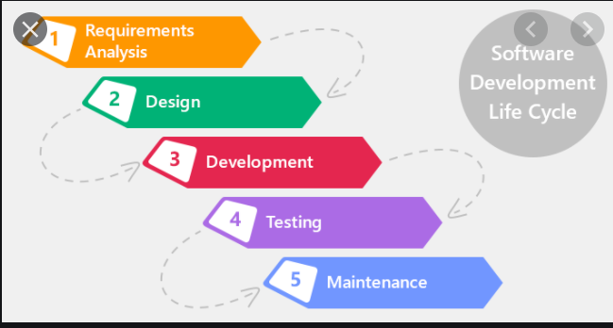

Waterfall Model
- In waterfall model, everything will happen at single shot
- Deliverables are committed with One time delivery
- Waterfall is suitable for small projects

Agile- we are following
- In agile Instead of delivering in a single shot, requirements will be delivered to the customer as incremental basis.
- Agile will be suitable for the big projects.
Customer requirements for the project will be collected.
Sprint Basis, Requirements will be split in small set of pieces.
Sprint means - Deliverable duration
We are following 3 weeks of sprint., we are delivering user stories 3 weeks once.

Product backlog-
The Product Backlog is specific to the entire goal of the product.

Sprint Backlog-
The Sprint Backlog is specific only to the Sprint goal in a particular Sprint.
Sprint Goal will remain the same for the Sprint while the Sprint Backlog may evolve during the Sprint subject to the Sprint.
IN THE BACKLOG SESSION, WE WILL MOVE THE PROJECT BACKLOG TO SPRINT BACKLOG .

Scrum master Product owner PO-
- Scrum master will monitor the progress of tasks and team
- He will conduct the scrum meeting and ask the updates of each task
- Product owner will represent the client
- He will monitor entire scrum team
- We need product owner approval to release the project to the customer

Team- Strength-
20 members as a team
Includes 12 developers, 6 testers, 1 lead and 1 manager

In Agile- We are having meeting-s like meet
We are following 3 weeks of sprint. Meeting workflow follows
- We have Sprint Planning (grooming)
- Walkthrough meeting
- Scrum meeting
- Sprint review
- Retro spectrum meeting
Sprint Planning (grooming)
Sprint planning, we will move the product backlogs to the sprint backlogs and prioritization will be done by the scrum master.
In sprint planning we will decide the stories which we are going to take as a part of next sprint
Walkthrough Meeting
Selected sprint backlogs and its functionalities will be discussed in the walkthrough meeting
- Development team lead
- Business team lead
- Testing team lead
- Client-side co-ordinator (On site Co-ordinator)
- Client – Product owner
My team will explain about the 10 stories and get approval from the client to pick the 10 stories for this current sprint.
Those Stories will be created as a JIRA ticket in the JIRA tool
Jira tickets are assigned to the resources
Scrum Meeting
- Daily basis follow-up of requirements and status of the user story which is working.
(Here all employees of the team have to provide the status).
- scrum meeting will happen on daily basis.
- Scrum meeting, we will discuss about each and every points status by resource wise
- We will update the status of the Jira ticket in the call
- If any clarification needed, then we can ask in the call
Moto of the scrum meeting discussion is about
- What was completed yesterday?
- What will get completed today?
- What is the plan for tomorrow?
Last day of the sprint, we will perform the sprint review and retro meeting will happen.
Sprint Review meeting
Completed points will get shown as demo to the product owner and reviewed in the meeting to ensure the completeness.
We have shown the demo of the product which the client discussed with us in walkthrough meeting
So based on the demo client will give their inputs
Retro- spectrum Meeting- (Retro Meeting):
Retro meeting will happen at last of the sprint, Purpose of the meeting is, how to improve the team performance and improve the quality of delivery by each sprint.
Existing issues and learnings will be discussed and apply the learnings in the upcoming sprints.
each resource of our team will discuss here
- What are the challenges we faced during the current sprint?
- What we learned in the current sprint?
- New automation/ new ideas may be discussing to overcome the release-oriented problems
- If any of situation, our release date extended then, or else any slippages in the release then those problem and solutions will be discussed in the meeting. These are the things we discuss in retro meeting
Scrum master and product owner and entire team will be in the meeting

Burn- down chart burndown-
- A burndown chart shows the amount of work that has been completed in an epic or sprint, and the total work remaining.
- Burndown charts are used to forecast time consumption to complete the pending tasks.

Agile Ensures Parallel processing – Advantages- of Agile model
- Parallel work of development team and testing team
- Requirements will come as Requirement Specification Document (RSD)
- Based on the RSD, Dev team will start the dev process, testing team will start the Test case preparations
- If dev team Delivers the build, then SIT will start execute the test cases which already prepared
- Instead of deliver all project points at single shot, agile ensures incremental delivery
- Continuous scrum meeting and customer meeting and follow-ups are used to come out from the mis-communications in the requirements.

TICKETING | JIRA
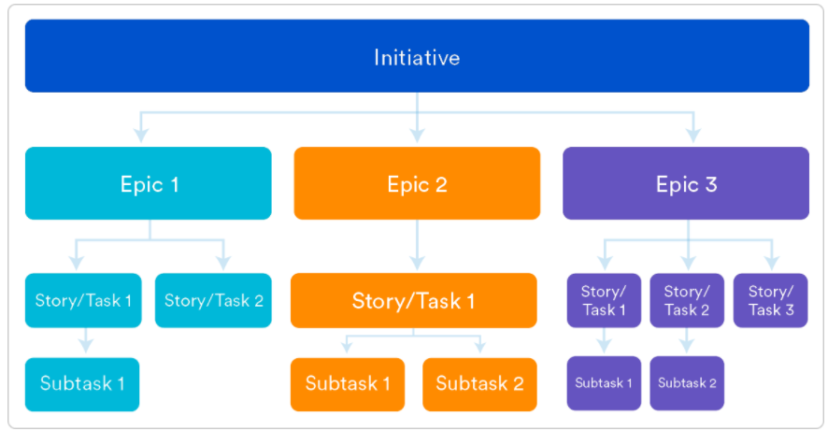

Epic- Story-
Epics- are larger bodies of the requirement
Epics will be broken down and created as stories
And Stories will be broken down and created as tasks and sub tasks
Those tasks will be assigned to us.

SQL

JOINS- JOIN-
Joins are used for combining fields from two or more tables by using columns common to each table with the help of primary key and foreign key relation.
It will check each record in the join condition with another table rows
So, it will do row level comparison
The join types we have are inner join, left outer, right outer, full outer and cross join and self join.
INNER- JOIN – Will bring matched records between the joining tables. For fetching matching records between two tables I’ll use the inner join in my project.
LEFT- OUTER– will show all records from the left table and matched records from the right table and unmatching will come as null. I will use the left outer join to fetch the unmatched counter party from the trading tables.
RIGHT- OUTER – will show all records from the right table and matched records from the left table and unmatching will come as null. To filter the unmatched legal entity I will use the right outer join.
FULL OUTER – It will give the both matched and un matched data from the both side tables.
We can select the both non matched data by using of the full join for example WHERE left side table column is null or right-side table column is null
In my project I have used the full outer join to filter out the unmatched legal entity and counter party details from bothy table. In order to that I need to use the is null operator in where condition.
CROSS- JOIN: It will combine each row of the first table with each row of the second table
Example if I have 100 rows in table1 and 10 rows in table2 then cross join will give 1000 rows as output.
To copy the same setup to the multiple branches
I will use the cross join to copy the all setup from the one branch to another branch,
so that it will generate the same setup data to the all branches
one branch is the having the setup of the transaction account
that set up I have to copy to all other branches
in that case I used the cross join to copy the same transcaiton se
SELF JOIN: If we join a same table twice with in itself twice in a query then it’s called self-join.
If we have both primary key and foreign key in a same table, we can able to use it.
I have used the self-join to select the currency name from the currency dimension and the fact table trade table having the from_currency_code and to_currency_code columns both in the same table and for that reason I have joined the currency dimension two times in the same table with the different alias.

SQL FUNCTIONS- FN- FUN-
I have used joins, aggregate functions, analytical functions, set operators, control statements, Character functions, number functions, date functions and general functions.

CONSTRAINTS-

Constraints are rules for the columns, that is used to block the invalid data entry to the columns.
Type of constraints, Primary key, foreign key, unique key, check and not null constraint
Primary- Key- pk- Only one primary key is allowed to a table. It will not accept duplicates and Nulls
Foreign- Key- fk-
- Multiple foreign keys allowed to a table and it accepts nulls and duplicates,
- it will refer the values from the primary key column.
- foreign key is used to ensure the data integrity in the tables

Unique- Key uk-

- IT will not accept duplicate values and it accepts null values.
- multiple unique constraints are allowed to a table

Not Null- It will not accept null values to the column, multiple not null constraints are allowed to a table
Check- It will accept the given values in the constraints. it will not allow the other values to the column
- example we can use the check constraint to the gender column
- male and female values
- and result column like true or false values

SET- OPERATIONS-
UNION- will club the results and it will eliminate the duplicates and it wil sort te data in asceding order of the first column.
UNION ALL– will club the results and it will retain the duplicates
INTERSECT- will show the common records from the both tables
MINUS- will show the data from the first table which are not available in the second table
I have used minus operation to find the missing data between the source and target.
To perform the set operations, number of column and data type of each column must be same in the all SQL
If number of columns mismatched then we have to use null or any default value to match the number of column and if the data type is not matched then we have to use the cast or to_char function to convert the data type.

CHAR- VS VARCHAR-
- Char is the fixed length
- it will not release the free space

- Varchar is the flexible length
- it will release the free space

SUB- QUERY- SUBQRY-
Subquery is query with in a query.
It allows us to use the result of another query in the outer query
We can narrow down the records selection in the inner query and process then in the outer query faster.
There are Normal and Co-related- Subqueries
In Normal subquery the inner most query will get executed first followed by the next outer layer query
In Co-related- subquery references columns in the parent query, then its result will be dependent on the parent query. In co-related subquery outer SQL will start first and for each record of the outer SQL inner SQL will get executed.
We can also use cslar corelated sub
We usually use exists and not exists in co-related subquery

Where- Vs Having-
- where clause is used to scan records in base table or physical table.
- having clause is used to scan records in result of group by clause
- Group by is used to group the data as per the group functions , to use the having clasue group BY is mandatory

Partition- by Vs Group by
- Partition by is used with the analytical function and it will process all rows
- It will partition the data as per the column, which mentioned in the partition by clause
- Group by is used along with the group functions.
- Non grouping column will be used in the group by clause and it will eliminate the duplicates by default.
- SO ITS SLOW
- Order by is used to sort the data based on the column

CASE- Vs DECODE- control statement
CASE | DECODE
CASE is a statement | DECODE is a function
In case we can able to use any relational operators | In DECODE only equals operator is possible  Means it will perform equality check only
CASE expects data consistency | But DECODE is not data consistency
CASE handles null differently  Means CASE will return FALSE if we compare null to null | DECODE handles null as null  Means it will return TRUE if we compare null to null

If is the cpondition and we canm be able to check any conditons using the sql also
Asnit wil be used in plsqls not in saql

CHARACTER- FUNCTIONS
INSTR-
REGULAR EXPRSSSION INSTRING
- Instring will give me number as output
- It will find the position of the given search pattern or character
- In this we will have four arguments (One is input string, then search character
then default value as 1 which indicated starting position, and finally we have no of occurrence)
- SYNTAX: INSTR (INPUT_STRING, SEARCH_PATTERN, STARTING_POSITION (DEFAULT 1), NO_OF_OCCURANCE)
SUBSTR-
- SUBSTRING functions allows you to extract a substring from a string
- SUBSTRING WILL RETURN CHARACTERS AS OUTPUT
- First parameter is the input string --
- Second parameter is the starting position
- And the third parameter is how many characters needed in the output
- Syntax: SUBSTR (INPUT_STRING, STARTING_POSITION, NO_OF_CHARACTER)
- If start position is 0, then the SUBSTRING function treats start position as 1 (i.e.: the first position in the string).
- If start position is a positive number, then the SUBSTRING function starts from the beginning of the string.
- If start position is a negative number, then the SUBSTRING function starts from the end of the string and counts backwards

GENERAL- FUNCTIONS
NVL-
- NVL accepts two arguments
- IF first argument is null it will replace it with the second argument
- If the first argument is not null then it will return the same value
- We can also use nvl in join conditions to apply default values for null

NVL2-
- NVL2 accepts 3 parameters ,
- If 1st one is not null then it return 2nd parameter.
- if 1st parameter is null then it prints 3rd parameter
NULLIF-
- it accepts 2 parameters,
- if both are same then it returns null, else it will return 1st parameter.
- NULLIF expects datatype consistency
COALESCE-
- It accepts N number of parameters, it will return first not null value
- COALESCE expects datatype consistency

CAST-
- CAST function in sql server is used to convert the value from one data type to another.
- SELECT CAST(25.65 AS varchar);
- SELECT CAST('2017-08-25' AS datetime);
- SELECT CAST(25.65 AS int);
- In ORACLE we have to_Date , to_number , to_char functions to convert the datatype
- TO_DATE – Will convert the varchar to system date format
- TO_CHAR – will convert number to varchar
- TO_NUMBER – will convert varchar to number

CTE-
- Common table expression is used to store the data into the single variable
- and that variable can be accessed multiple time in the same sql
- common table expression is denoted by WITH clause
- CTE can be more readable
- if the subqry needs to be used multiple time in the same outer sql then ,we can use the common table expression
- This will hit the db onetime and it will store the data in the variable and that can be used from the mutliple times
- Number of time DB hit is reduced by using of the common table expression.
- Temporary is the session based tables. It wil hold the data til that session alone.
- To worte compelx logics,w e wil wiorte temporay tables

CTE- VS- SUBQUERY
CTE is the common table expression, result of the inner query will be stored in the variable , that variable can be accessed multiple time in the same sql.
CTE is mentioned by WITH clasue.
CTE is reusable by design
We can store the result set data into a variable and access it multiple times inside the same SQL multiple times.
This will decrease the number of DB hits as well.

CLAUSES-
- SELECT- Should be followed by column name
- FROM- Should be followed by table name or inline subquery
- WHERE - Table filter condition
- GROUP BY - To group data in a column
- HAVING - To filter group by output
- ORDER BY - To sort the output based on any columns in ascending or descending order
- If no specific order is given then order by will default take ascending order

DISTINCT-
- It will return us only unique values in the columns used

DUAL-
- Oracle inbuild table will have only one row and column by default
- And the default value is 'x'
- In runtime we can able to store value in dual but not permanently

ROWNUM- to print serial number I use rownum
- It always starts with 1 and will be in sequential manner
- Rownum generation is based on the result set of a query
- Rownum will be shuffled if will use order by

ROWID-for identifyin duplicates
- Permanent address of a row
- 18-digit alpha numeric string
- And its unique from one another with case sensitiveness

GROUP- FUNCTION /AGGREGATE FUNCTION
- Columns used in group functions are only allowed in select clause
- If we want to use other column in select clause then we have to use that column inside a group function
- But its not mandatory to use all the columns used in group by in select clause
- Having clause is used to filter the result set of group by.
Analytical functipns are used to rank the values
GROUP FUNCTIONS : MIN , MAX ,AVG , SUM , COUNT(COLUMN_NAME) , COUNT(*)
COUNT-(COLUMN_NAME) WILL GIVE THE COUNT OF NOT NULL VALUES IN THE COLUMN USED
COUNT(*) WILL RETURN TOTAL TABLE COUNT

Duplicate- selection
- I will select columns in which we need to find the exact duplicates and group by with the same columns
- Then by using of the having clause I will select the more than one entry of the data in the columns
- If we have not used the having clause then it will give the distinct of the columns used in group by
- Select column, count (column) from table group by column having count (column) >1 ;

Duplicate- Deletion
- I have used rowid to select the duplicates, I will select the max of row Id in the each group and I used the not in to remove all other rowid from the table. This sql will work in the oracle database,
- if that is not in the oracle then, I will use the common table expression to delete the duplicate data.
- Oracle:
- Delete from emp where rowid not in (select max(rowid) from emp group by empid ) ;
- Other DB
- With e as ( select empid, row_numner () over (partition by empid order by empid ) r1
From emp ) delete from e where r1 >1 ;

ANALYTICAL- FUNCTIONS

1.RANK-
- Rank method will give rank based on the values in the column.
- The RANKS may not be consecutive. Because if the current rank as duplicates, then the next rank will be skipped.
- An ORDER BY clause is required when working with RANK functions, but a PARTITION BY clause is optional
SYNTAX : RANK ()OVER(PARTITION BY COL_NAME ORDER BY COL_NAME )
RANK ()OVER(ORDER BY COL_NAME )
2.DENSE_RANK-
- The DENSE_RANK is consecutive.
- Even if the current rank as duplicates the next rank will not be skipped.
- An ORDER BY clause is required when working with DENSE_RANK functions, but a PARTITION BY clause is optional
- I have used the dense_rank to rank the counter party as per the payment completion the same ranking I have performed in the branch wise data by using of the partition by clause
SYNTAX : DENSE_RANK () OVER(PARTITION BY COL_NAME ORDER BY COL_NAME )
DENSE_RANK ()OVER(ORDER BY COL_NAME )
3.LEAD-
- The LEAD function is used to access data from NEXT rows along with data from the current row
- An ORDER BY clause is required when working with LEAD and LAG functions, but a PARTITION BY clause is optional
- I have used the lead function to get the next payment amount for the trade and I have compared the payment difference between the pervious payment and current payment and I have selected the difference in the output
SYNTAX : LEAD (COLUMN_NAME , NO_OF_POSITION , NULL_HANDLER)OVER(ORDER BY COLUMN_NAME)
4.LAG-
- The LAG function is used to access data from PREVIOUS rows along with data from the current row.
- An ORDER BY clause is required when working with LEAD and LAG functions, but a PARTITION BY clause is optional
- I have used the Lag function to get the previous payment amount for the trade and I have compared the payment difference between the current payment and previous payment and I have selected the difference in the output

SYNTAX : LAG (COLUMN_NAME , NO_OF_POSITION , NULL_HANDLER)OVER(ORDER BY COLUMN_NAME)
5.ROW_NUMBER-
- It always generates unique ranking even with duplicate records
- WE CAN USE THE ROW NUMNER TO NUMNER THE BRANCHES AND IN THE PARTIITON BY OF THE SOME OTHER COLUMN
SYNTAX : ROW_NUMBER() OVER(partition by colimn_name ORDER BY COLUMN_NAME )
We have a partition by
6.LISTAGG-
- The Oracle LISTAGG () function is an aggregation function that transforms data from multiple rows into a single list of values separated by a specified delimiter.
- The Oracle LISTAGG () function is typically used to de-normalize values from multiple rows into a single value which can be a list of comma-separated values
- select job_id , LISTAGG( first_name ,',') WITHIN GROUP (ORDER BY first_name)
- from employees
- group by job_id;

REGEXP_LIKE-
REGEXP_LIKE(column_1, '![A-Z] [a-z]')

SQL LANGUAGES-
DDL – Data definition language
DML – Data manipulation language
TCL – Transaction control language
DCL – Data control language
DDL-
Data Definition Language is used to define the database structure or schema
Create, Drop, Alter, Truncate, rename are DDL Statements
These are auto commit statement
- CREATE is to create objects in database
- ALTER is to alters the structure of database
- DROP is to delete objects from database
- RENAME will rename the objects
- TRUNCATE will clean up the data from the table and retains the structure
DML-
Insert, Update, Delete, Select, Merge are DML statements
These are not auto committed statement
Its required commit to save the transa
- INSERT– It will Insert data into a database table.
- UPDATE–will update existing records within a table
- DELETE– Will Delete unwanted records from a table
- MERGE– is used to perform the both insert and update in the single action and if the condition or data is matched then we can do the update and it is not matched the we can do the insert in the single transaction.
DCL-
Grant, Revoke are DDL statements
- GRANT– It permits users to access the database.
- REVOKE– This SQL DCL command withdraws the permission given by GRANT to access the database.
TCL-
Transaction Control Language commands are used to manage transactions in the database. These are used to manage the changes made by DML statements.
Commit, Rollback are TCL statements
- COMMIT– This SQL TCL command will commit the running transaction
- ROLLBACK– Rollback the current transaction
- SAVEPOINT– It’s a point in a transaction in which you can roll the transaction back to a certain point without rolling back the entire transaction.

DROP-
- DROP is a DDL statement
- If we drop a table then it will be permanently removed from the database
TRUNCATE- is a ddl
- TRUNCATE will remove the data from the table
- And keep the structure of the table
- Truncate will be faster than delete
- But we cannot able to delete specific rows from a table
DELETE-
- Delete is a DML statement
- We can able to delete a specific row or the entire rows from a table using DELETE
- Delete requires commit to save the transaction
- Delete structure will remain the same

ODS-
- An operational data store (ODS) is a central database that provides a snapshot of the latest data from multiple transactional systems.
- The ODS is architected to provide a consolidated view of data integrated from multiple systems
- An ODS may be used as an interim area for a data warehouse
- it sits between the data sources and the data warehouse

INDEX-
I WILL USE INDEXES IN THE COLUMN USED IN WHERE CLUAE
An index in ORACLE is a performance-tuning method of allowing faster retrieval of records. An index creates an entry for each value that appears in the indexed columns. By default, Oracle creates B-tree indexes.
- B-TREE INDEX (balanced tree index)
There are branches from the top that led to leaf nodes that contains data. The B-tree structure is from branches to leaf nodes.

- BITMAP INDEX
It will be created on less distinct value column
Example: When there are 1 to 10 distinct values the bitmap indexes are very useful. It will improve the performance of query drastically.
But if the distinct values are more than bitmap performance will be less.

- UNIQUE INDEX
It will not allow duplicate in the column and creates rowed based index

- FUNCTION BASED INDEX
We can able to use character functions like Upper, Lower, Initcap and so on in creating the index. So, if we use that specific function in filter condition then function based index will work effectively.
In SQL Server we have Clustered and Non-Clustered index
1. Clustered- Index:
Clustered index has to maintain the physical order of the stored records according to the indexed column. We can have only one clustered index for a table and it will not allow the nulls and duplicates in the column.
2. Non-clustered Index:
A non-clustered index doesn’t sort the physical data inside the table. In fact, a non-clustered index is stored at one place and table data is stored in another place. We can have multiple non clustered index to a table and it will allow the nulls and duplicates to the column.

ACID-
Every Transactions we do in the database access data using read and write operations.
In order to maintain consistency in the database, before and after the transaction, certain properties are followed. These are called ACID properties

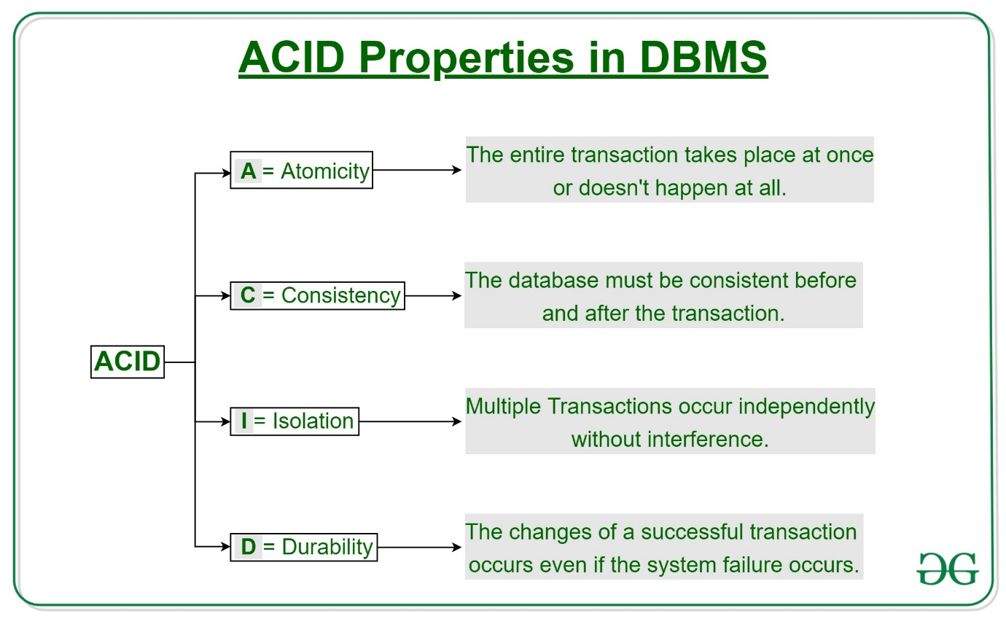
Atomicity
- It means that either the entire transaction takes place at once or doesn’t happen at all. There is no midway
- Atomicity is also known as the ‘All or nothing rule’.
Consistency
- This means that integrity constraints must be maintained so that the database is consistent before and after the transaction.
Isolation
- This property ensures that multiple transactions can occur concurrently without leading to the inconsistency of the database state. Transactions occur independently without interference.
Durability
- This property ensures that once the transaction has completed execution, the updates and modifications to the database are stored in and written to disk and they persist even if a system failure occurs. These updates now become permanent and are stored in non-volatile memory.

Data mining-
Data mining is the process of analyzing data from different perspectives and summarizing it into useful information –
For example, we can analyze the past year sales data and we can plan the discounts for the set of products which were not met in the sales target. This kind of patterns we can discover from the data mining process.
information that can be used to generate BI reports that helps in increase revenue, decision making, cost cutting, etc.,
It allows users to analyse data from many different dimensions or angles, categorize it, and summarize the relationships identified. Technically, data mining is the process of finding correlations or patterns among dozens of fields in large relational databases.

Python- Py-
Set, dictionary
No, a SET in Python cannot contain duplicate elements
Dictionary is a built-in data type that stores a collection of key-value pairs. Each key in a dictionary must be unique, and it is used to retrieve the corresponding value

 | Python Lists | Python Tuples
1 | List are mutable | Tuples are immutable
2 | Iterations are time-consuming | Iterations are comparatively Faster
3 | Inserting and deleting items is easier with a list. | Accessing the elements is best accomplished with a tuple data type.
4 | Lists consume more memory | Tuple consumes less than the list
5 | Lists have several built-in methods. | A tuple does not have many built-in methods because of immutability
6 | A unexpected change or error is more likely to occur in a list. | In a tuple, changes and errors don't usually occur because of immutability.

Air flow- airflow-
- Its used for scheduling and maintaining complex data pipelines
- Its used for define, schedule and monitor the workflow as DAG’s (Directed Acyclic Graphs)

SQL Query-

Select * from (
Select empid, ename , salary, dense_Rank() over(order by salary desc ) r1
From emp ) where r1 =3
I have used the dense_rank to rank the salary and I used the alias as dr and I used the outer sql to select the 3rd ranked data in the output.

UNIX-
Grep- is used to find the patterns from the file and also we can use the egrep to find the multiple patterns from the file
Sed- is used to do the find and replace the string in the file and also we can use sed to insert the lines to the file and also the print set of lined from the file
Find- is used to find the files form the directory by using of the name or size or creation date or modified date
AWK- is used to print a column or set of columns from the file.
CHMOD- is used to give the permission to the file, like we can provide the read, write and execute permission to the user, group and others to the particular file or directory
For read (4) and write (2) and execute (1) for the number notation.

Query profile

How will you connect power bi

AWS glue
Array construct
Object construct
Data unloading – multiple files into diff location
Source as file and must extract as xml file while providing to Client
Pipe real time scenarios
Max file size accepted by s3
Alert
Object tagging
Pipe inside proc
alert creation for each error – task fail, pipe fail
tariff management
role creation and assigning?
External Tokenization
Data sharing
Green field implementation – steps
Data modelling?
Comma separated files, extra data in one single cell.
System stream data, it will load only I fthe stag eha sthe data

built functions for trigerring mail using alert in snowflake
edit
spilling
generator
thread
regions
query pruning
parameter binding
zip file can eb handled in sf? Is yes, how?

Sql Server integration services – SSIS-
I will work with ssis team
So they help to load the etl jobs.
In our project Developers used ssis to migrate the data ..
I will do the manual validation for ssis integrations
I used ssis to open the dts packages and understanding the flow of the data.

